

CLOUD COMPUTING

LAB FILE SUBMMITED BY:SUBMMITED TO:

NAME: SAIRANJAN SUBUDHI DR. AMBIKA AGGARWAL SAP ID: 500101861

BATCH: 2

**Experiment-1**

**Introduction to AWS Identity and Access management**

After logging into the AWS account, we will begin by searching the IAM service in the console.

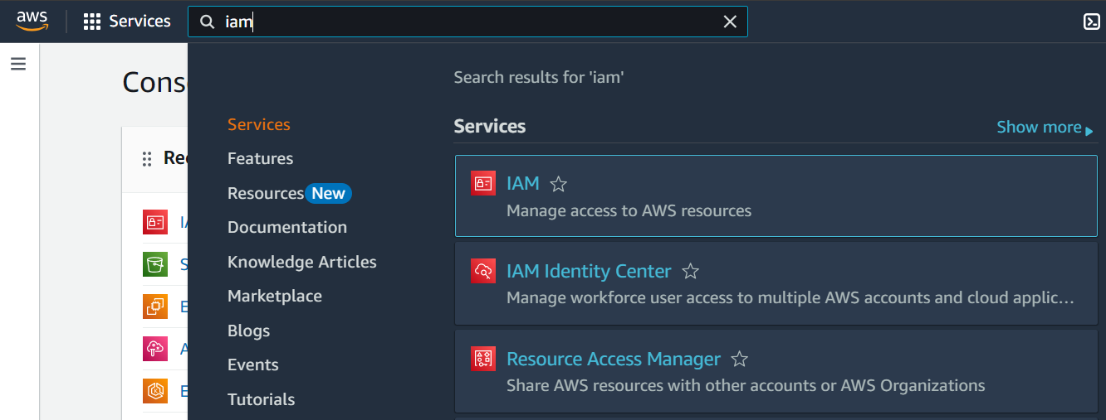

Our first task is to create 3 different IAM users. While creating the users, we will allocate the permissions accordingly.

**User1:**

* First, we are creating an IAM user with the name “sai-user1”. Here, we have assigned a custom password to sai-user1.

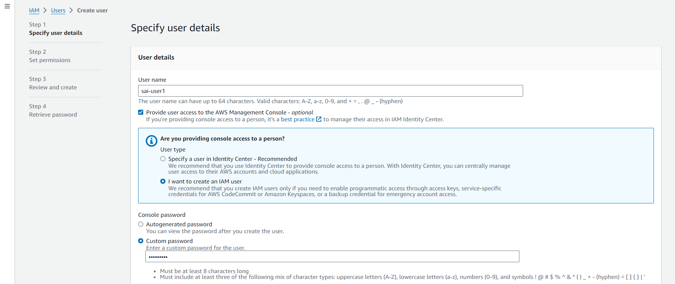

* Here, we are setting up the permissions for sai-user1.

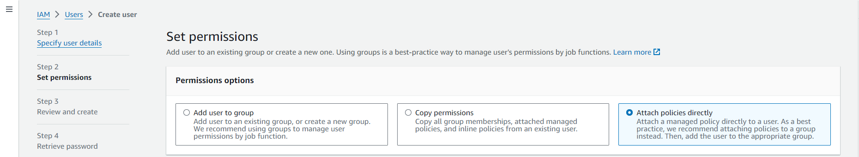

* We will be creating an EC2 instance further for which user-1 will only have the read only access to it.

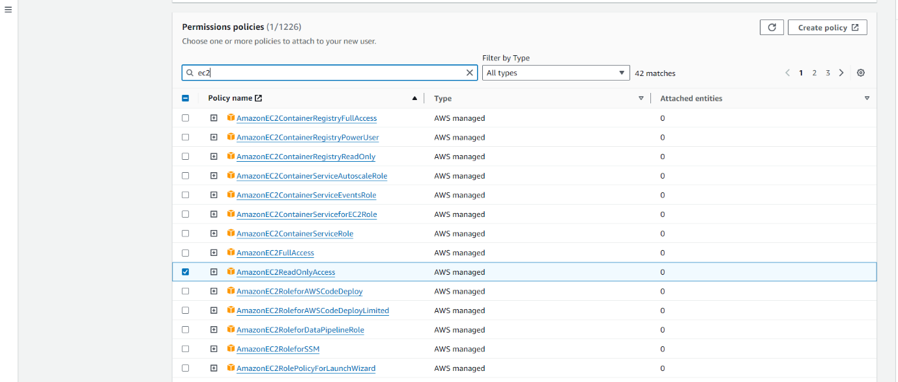

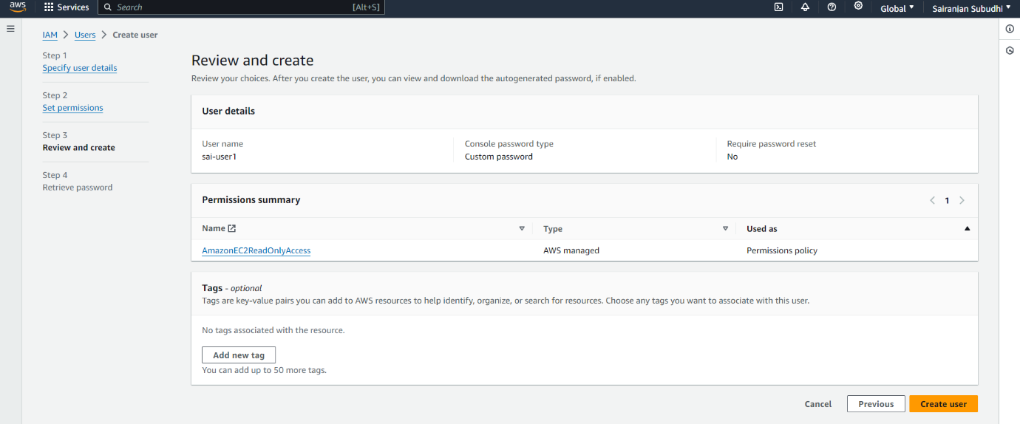

* After creation of sai-user1 as IAM user we will be copying the URL and sign in to AWS account as an IAM user.

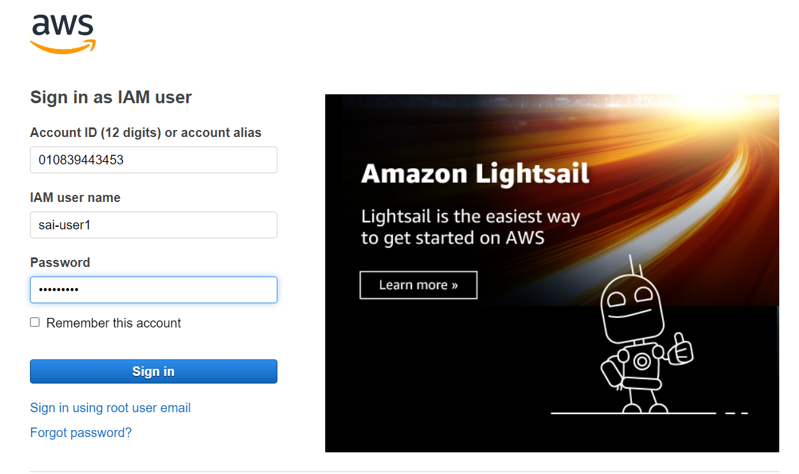

* After logging in as IAM user this is the look of console.

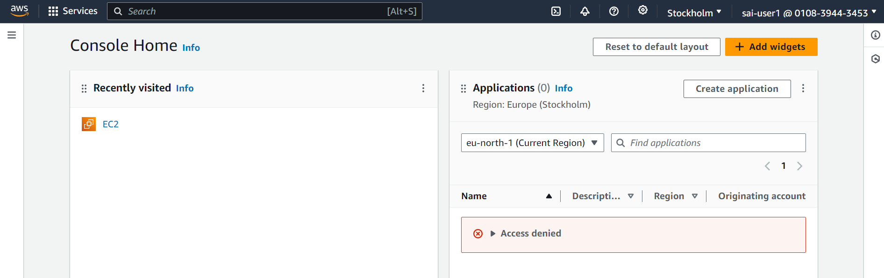

* Now we will try to launch an EC2 instance, with sai-user1.

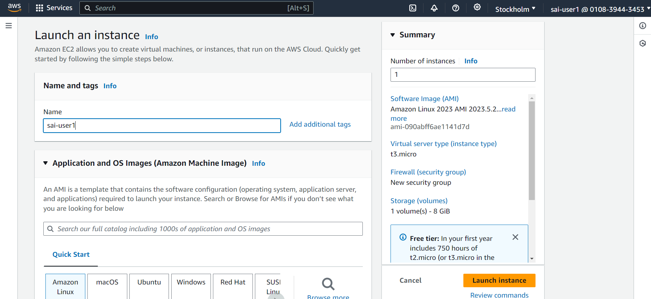

* Since we have given EC2ReadOnlyAccess to sai-user1, it will not be able to launch an EC2 instance.

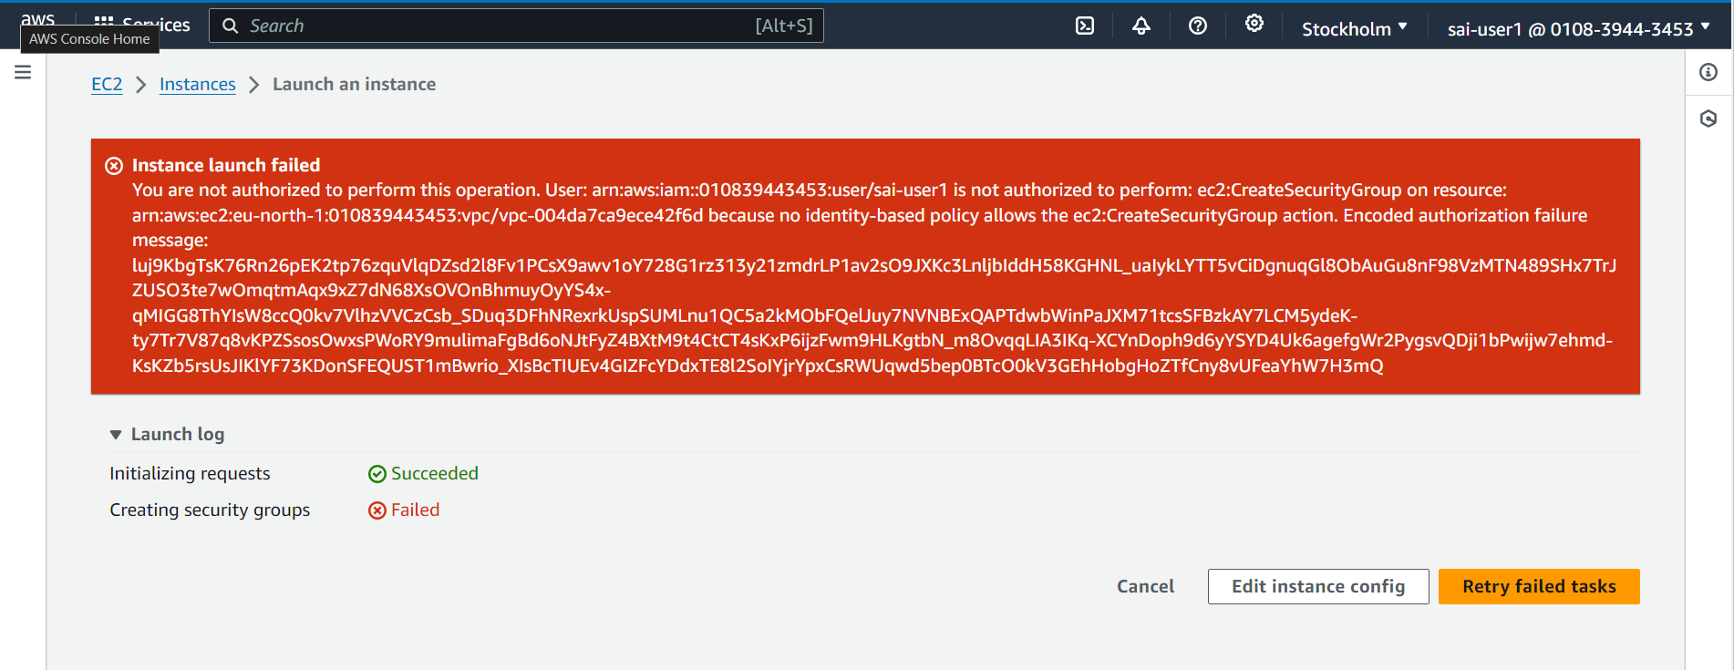

**User 2:**

* Now, we are creating an IAM user with the name “sai-user2”. Here, we have assigned a custom password to sai-user2.

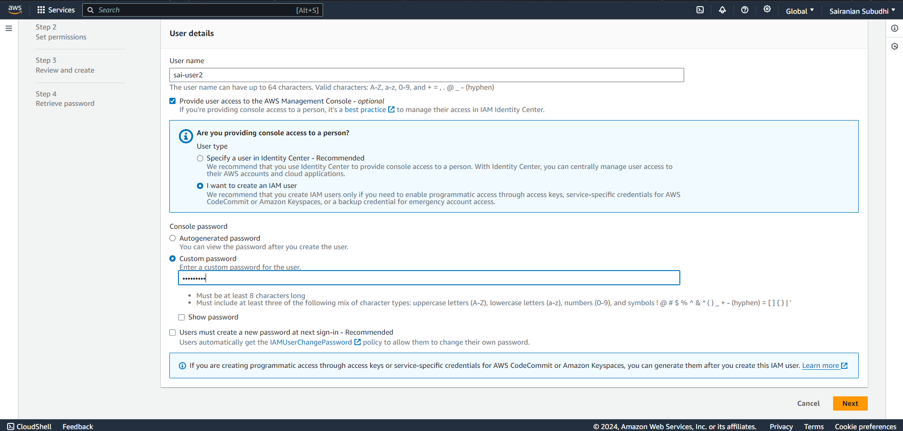

* Here, we are setting up the permissions for sai-user2. We will be creating an EC2 instance further for which user-2 will have full access now.

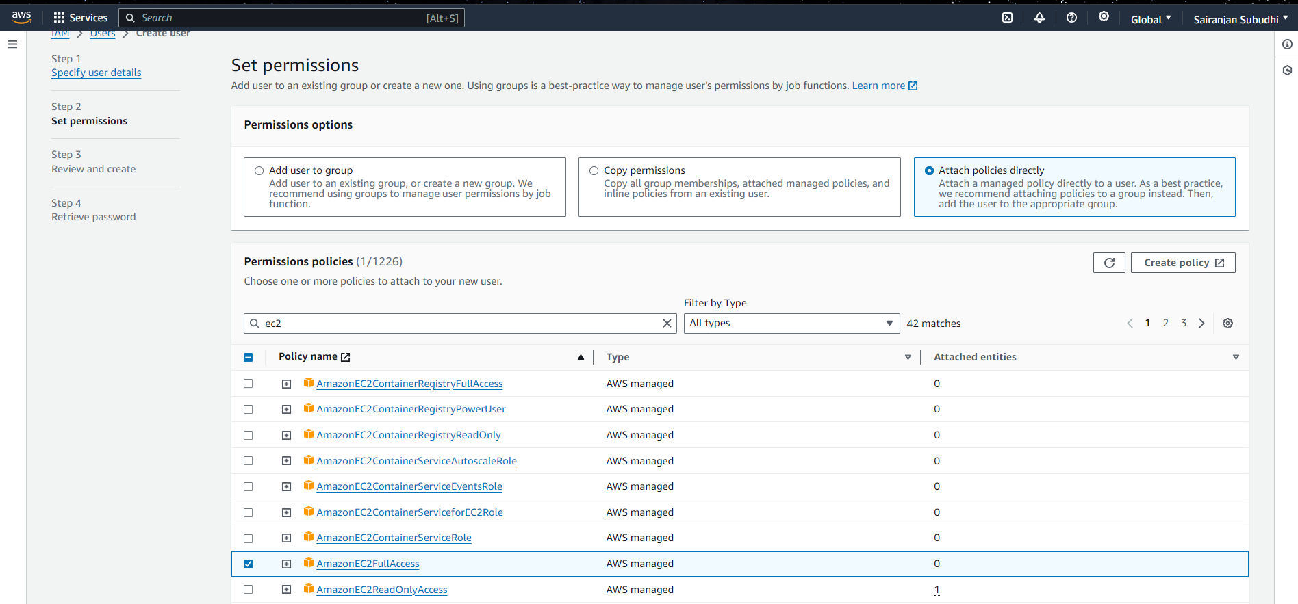

* Sai-user2 is successfully created.

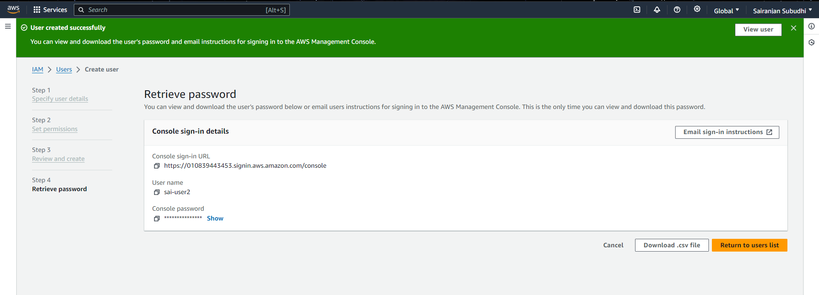

* After creation of sai-user2 as IAM user we will be copying the URL and sign in to AWS account as an IAM user.

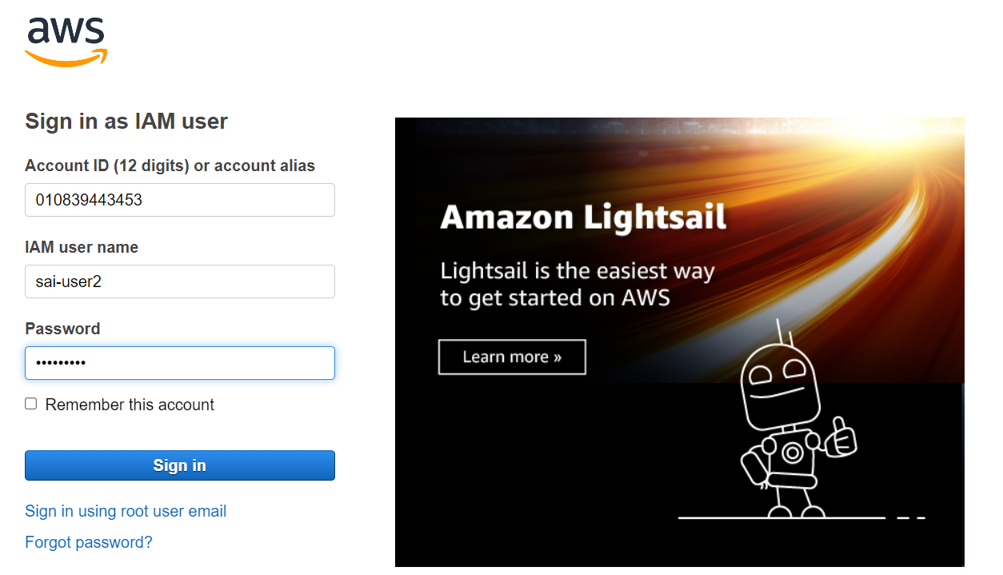

* After logging in as IAM user this is the look of console.

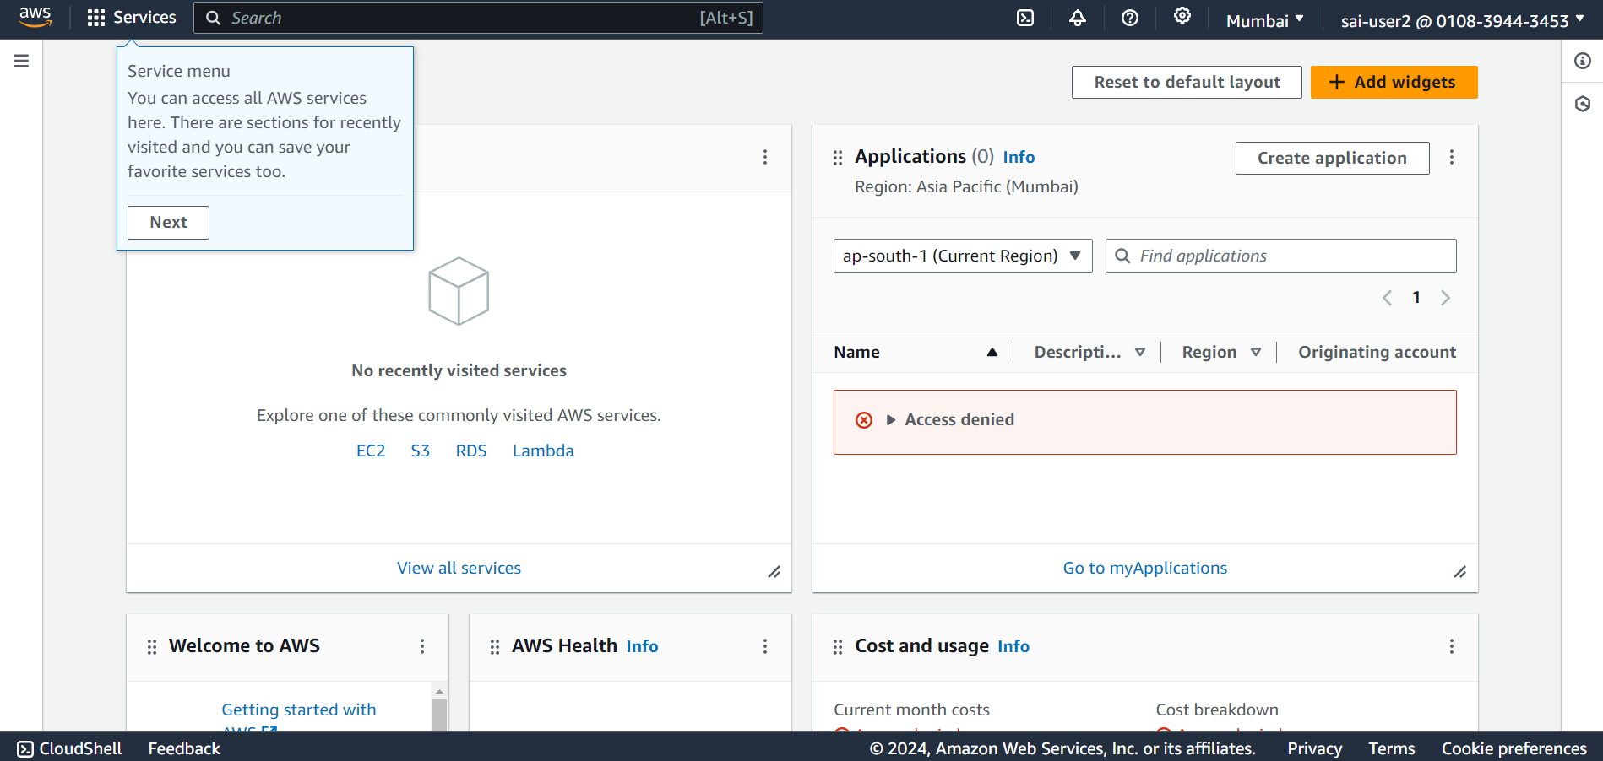

* Now we will try to launch an EC2 instance, with sai-user2.

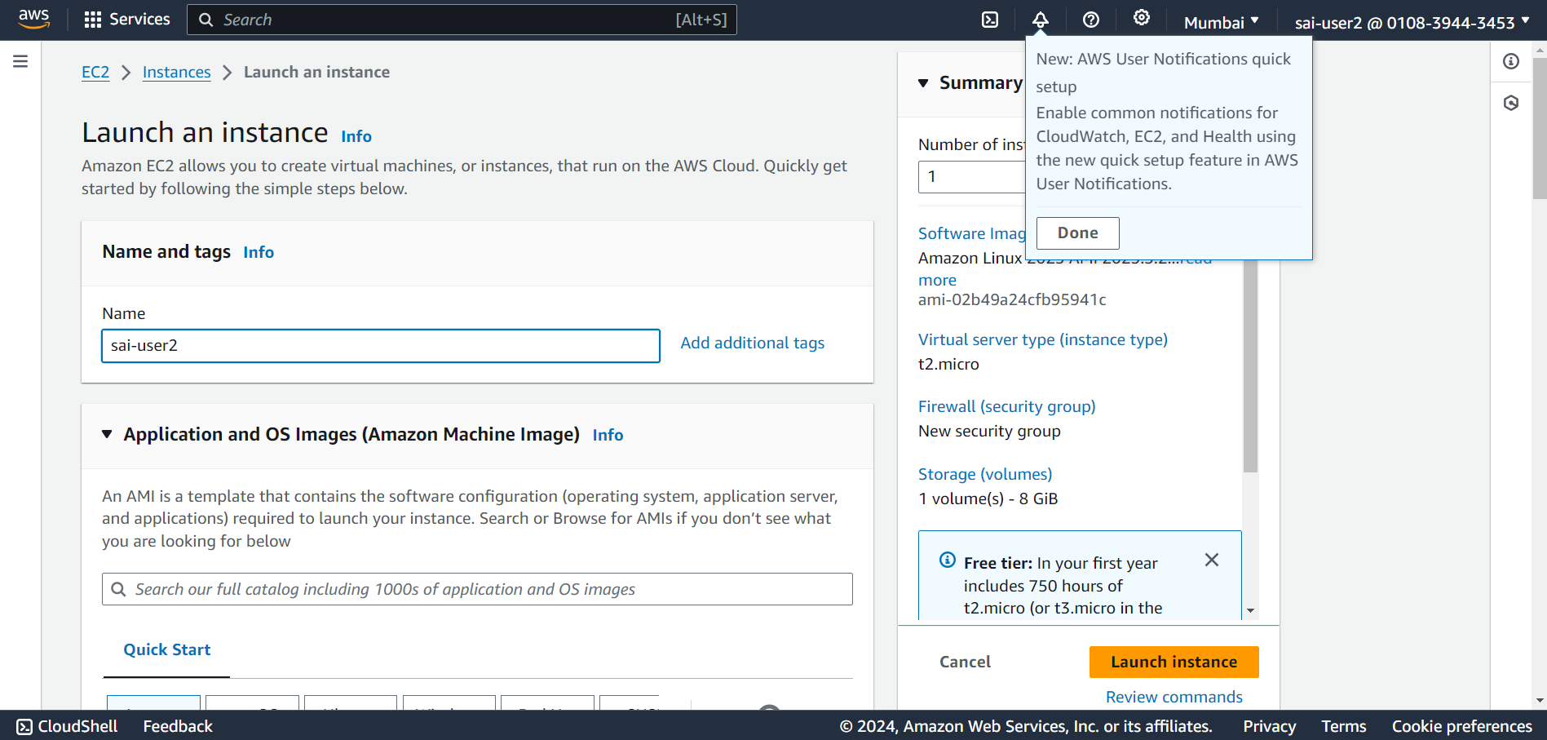

* Here, as we have given the EC2FullAccess to sai-user2, we were able to launch a EC2 instance.

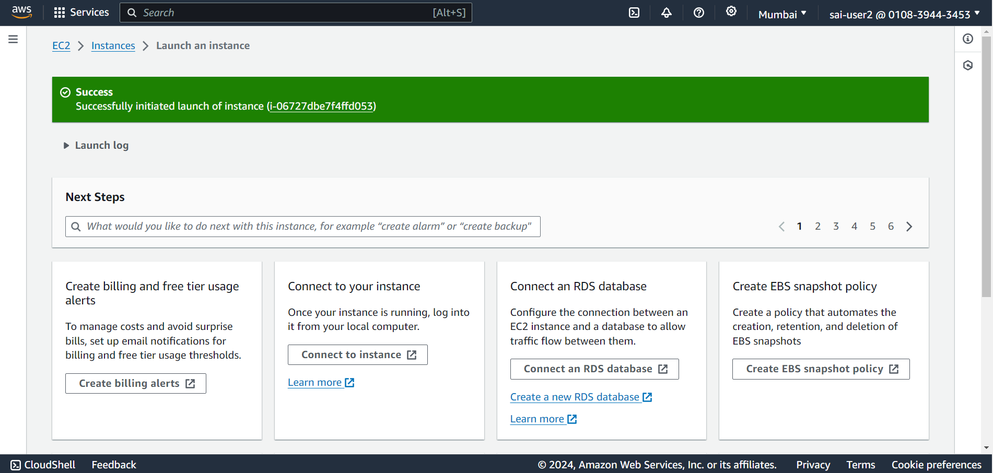

**User 3:**

* Now, we are creating an IAM user with the name “sai-user3”. Here, we have assigned a custom password to sai-user3.

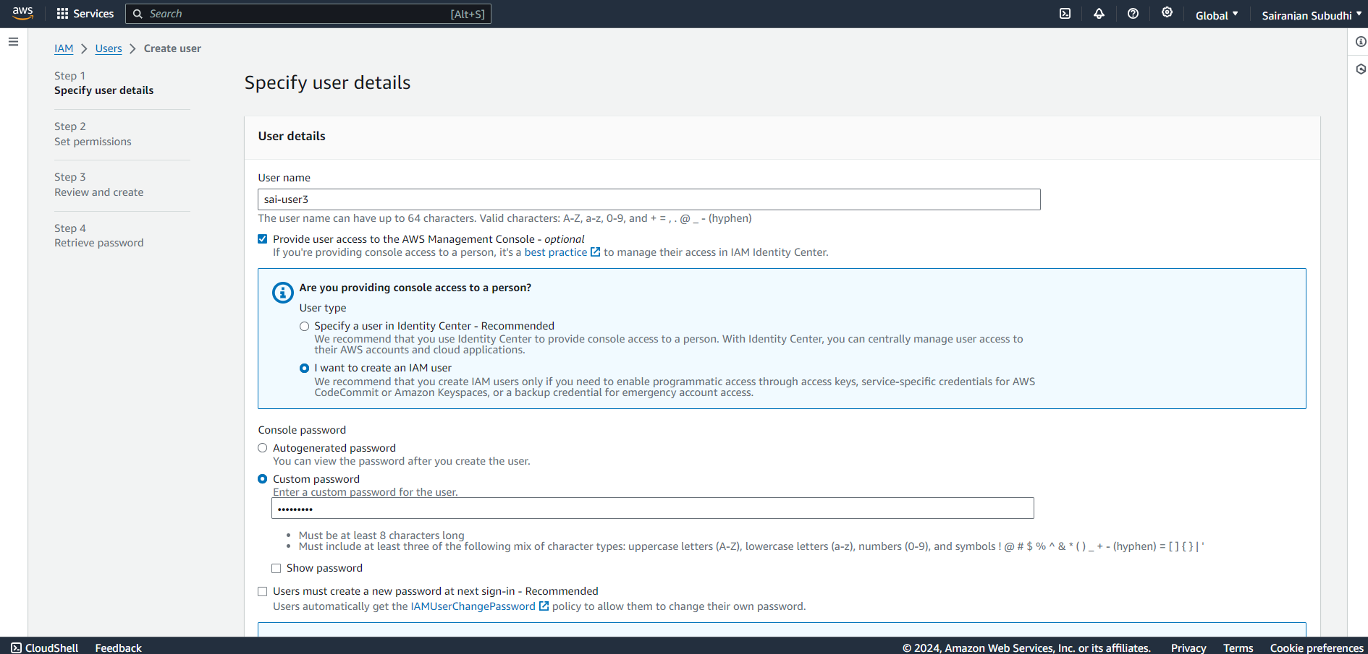

* Here, we are setting up the permissions for sai-user3. We will be creating a S3 bucket further for which user-3 will have full access now.

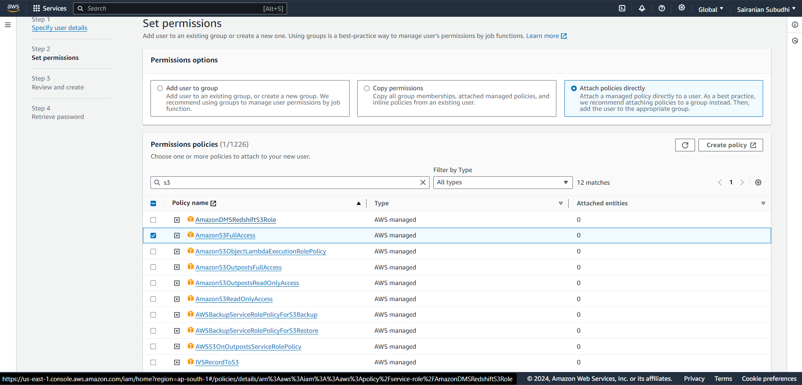

* Sai-user3 is successfully created.

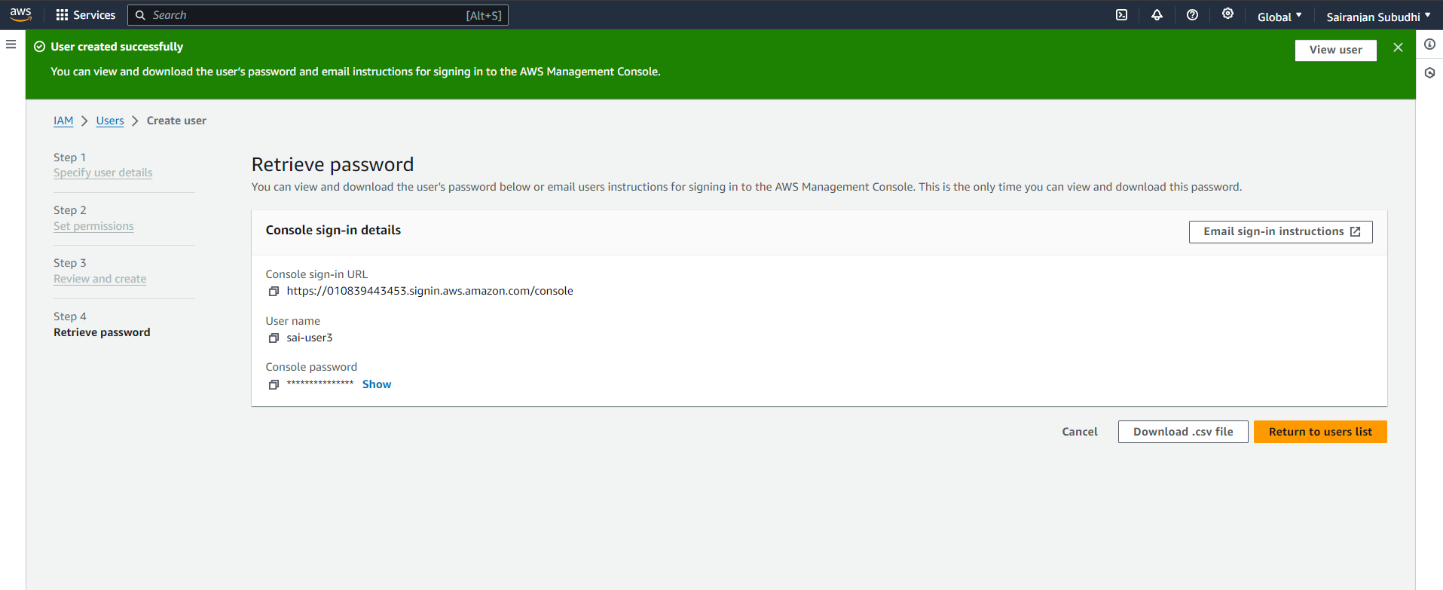

* After creation of sai-user3 as IAM user we will be copying the URL and sign in to AWS account as an IAM user.

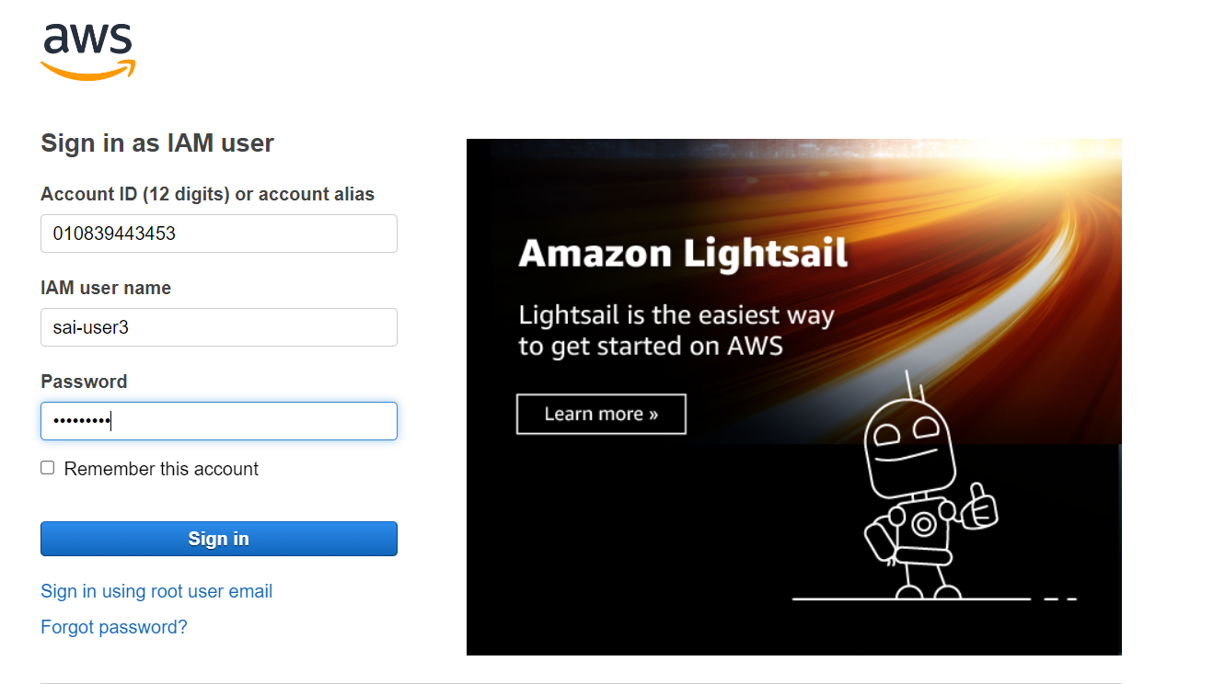

* After logging in as IAM user this is the look of console.

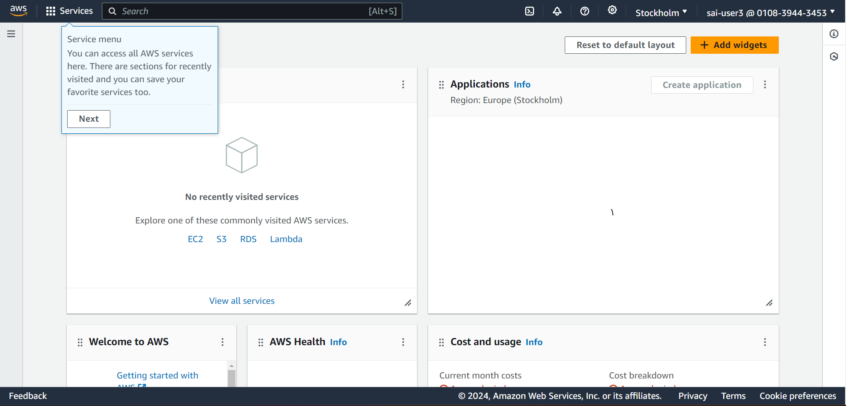

* Now we will create a S3 bucket, with sai-user3.

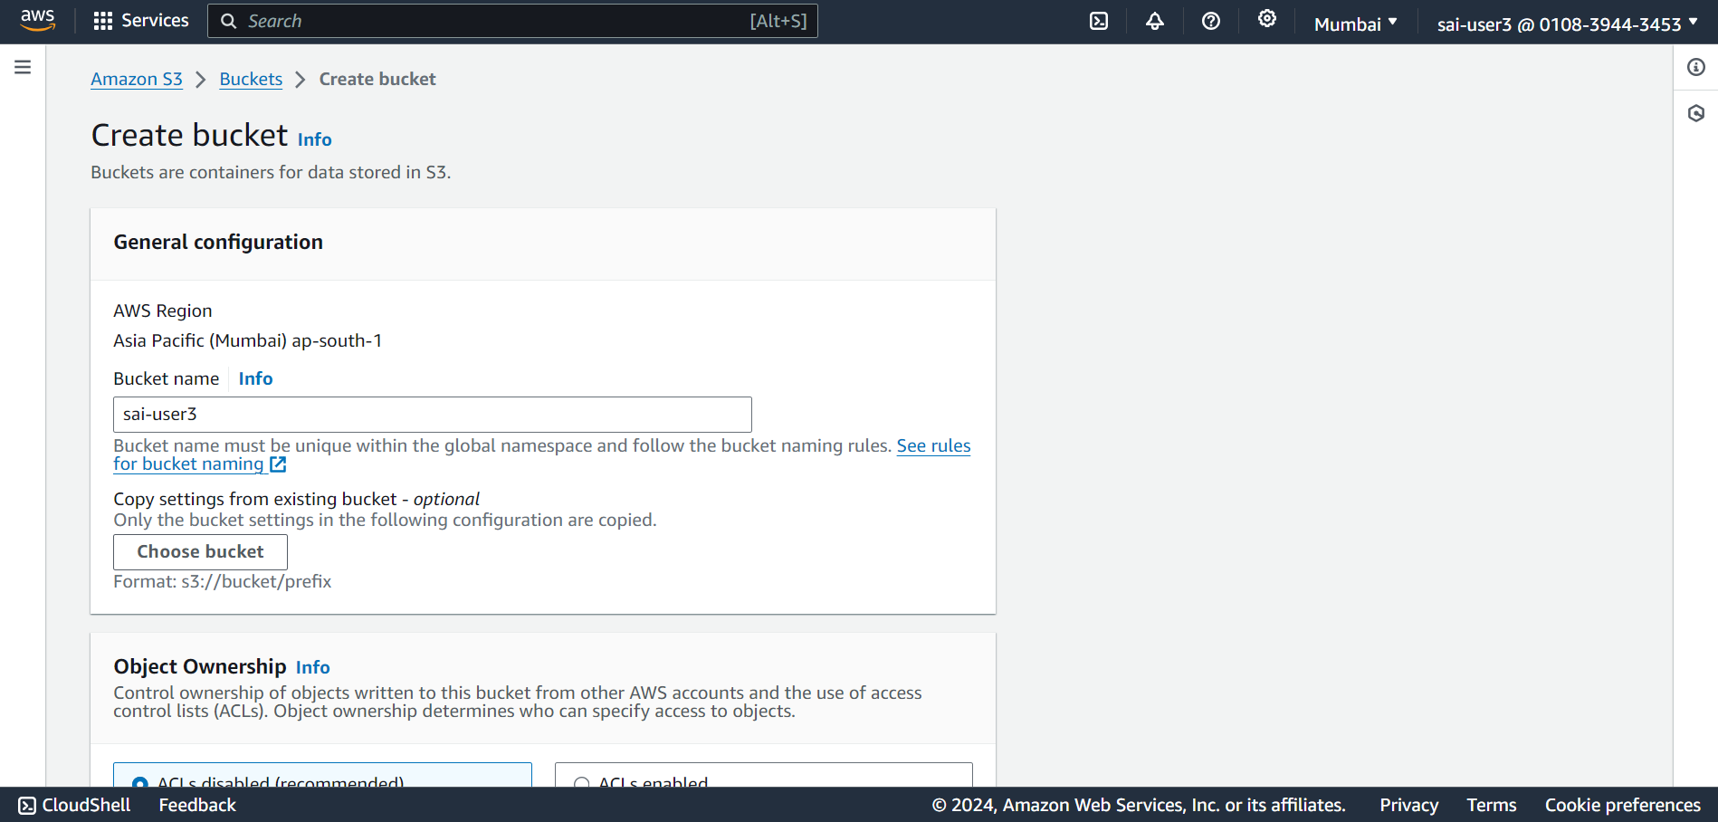

* We have successfully created the S3 bucket as we have already given S3FullAccess to it while creating the user.

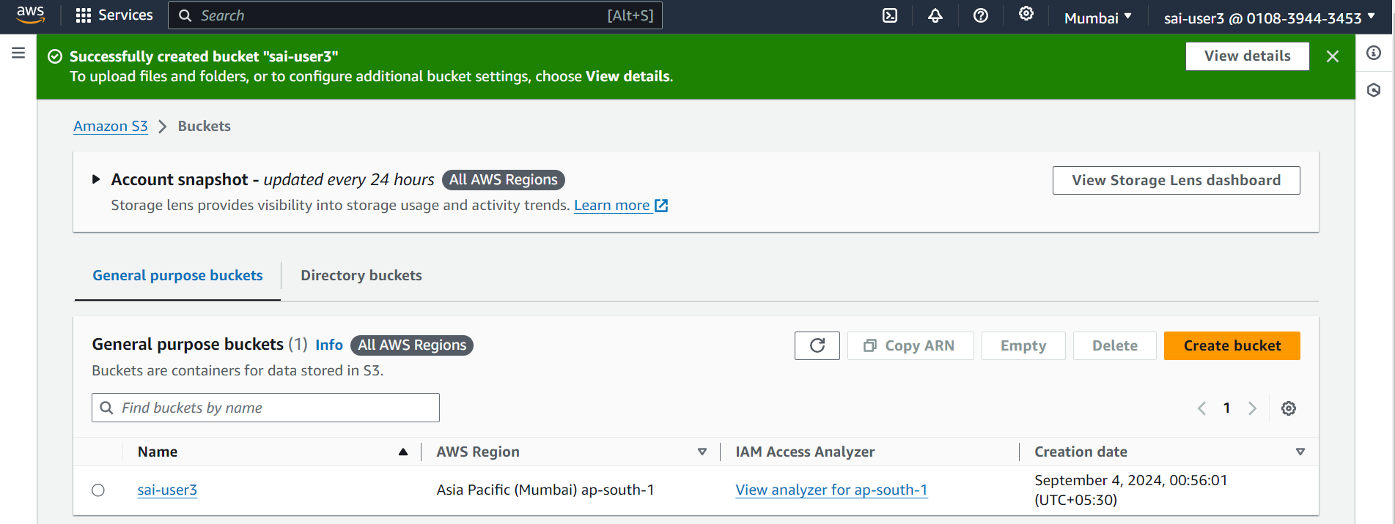

* Here, we are creating a user group with all the three IAM users and giving EC2FullAccess permission to the group.

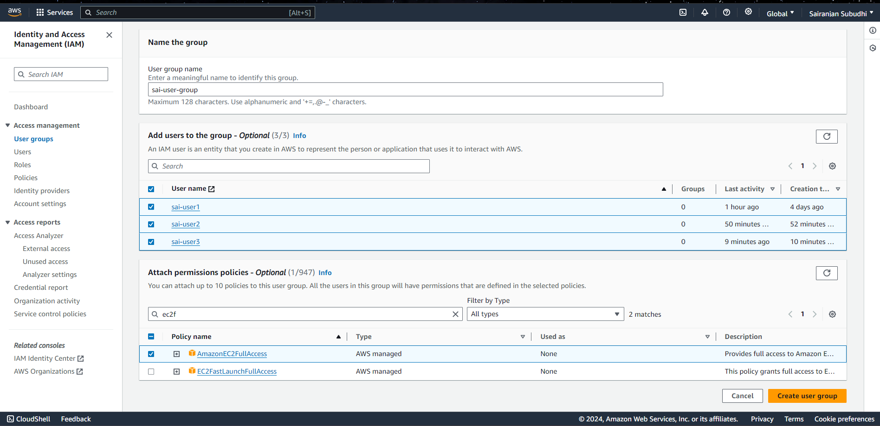

* Checking the sai-user1 whether the EC2FullAccess permission has been set or not.

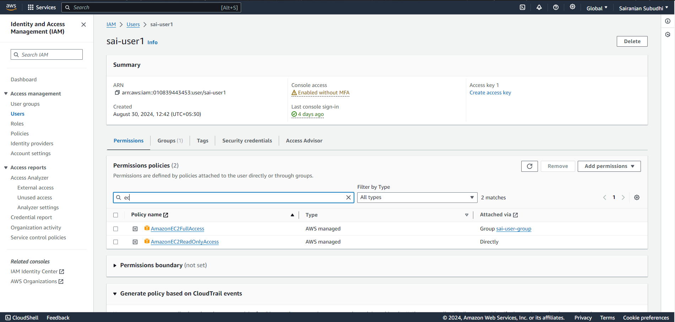

* Now, we are checking if we are able to launch EC2 instance with sai-user1, since we were unable to launch it before. Here, we are now able to launch EC2 instance.

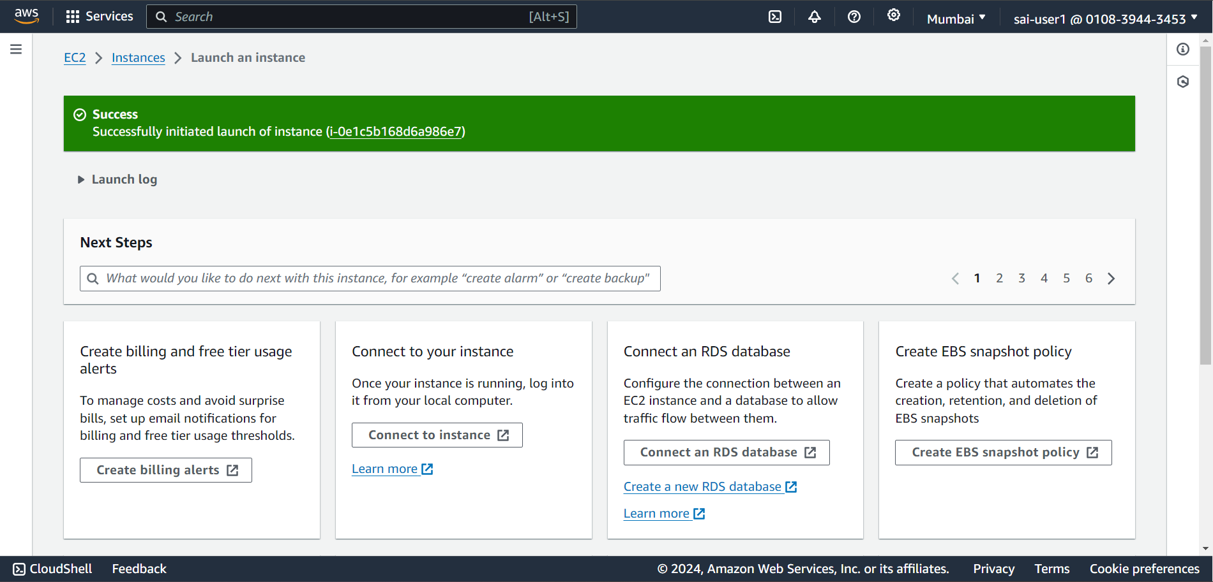

**Experiment-2**

**S3 multi-region storage backup with cross region replication**

Create a S3 bucket with default region (general purpose) and enable ‘bucket versioning’.

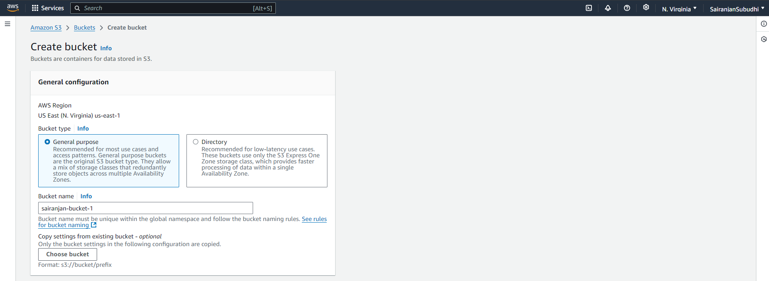

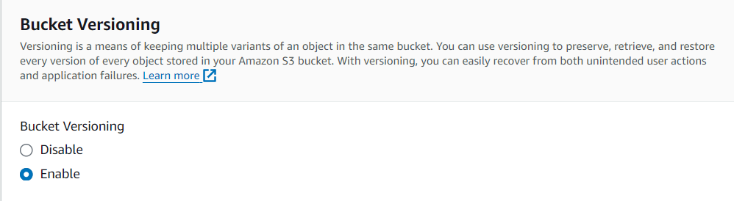

Bucket 1 created successfully with name ‘sairanjan-bucket-1’

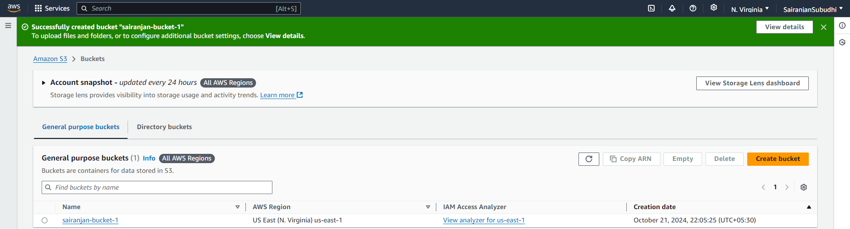

Now change region to ‘Europe(Stockholm)’ and create another bucket

Enable ‘bucket versioning’ for the second bucket too.

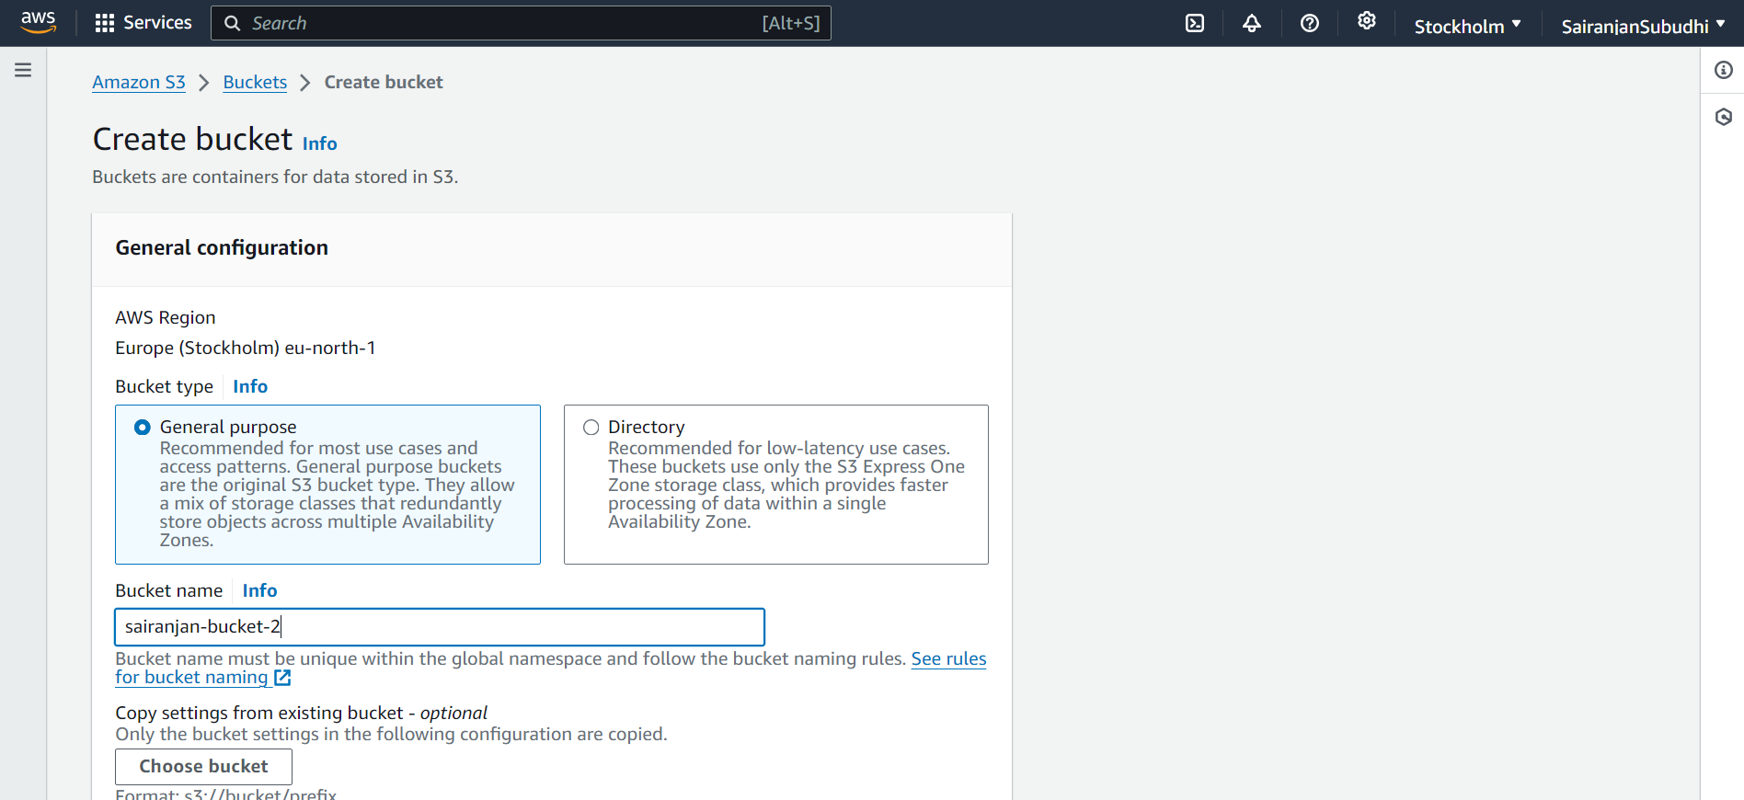



Available buckets in different regions -

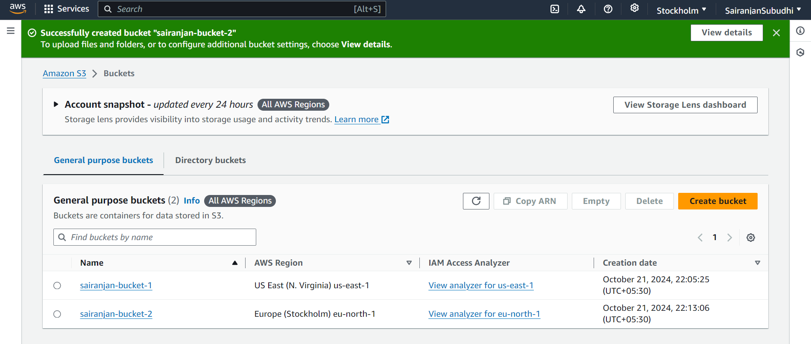

One will serve as source bucket and another will serve as destination bucket.

Go to ‘sairanjan-bucket-1’ under ‘Management tab’ > ‘Replication rules’. All objects in source bucket will be replicated automatically in a destination bucket if replication rules are set.

* Create replication rule – *‘rule1’.*

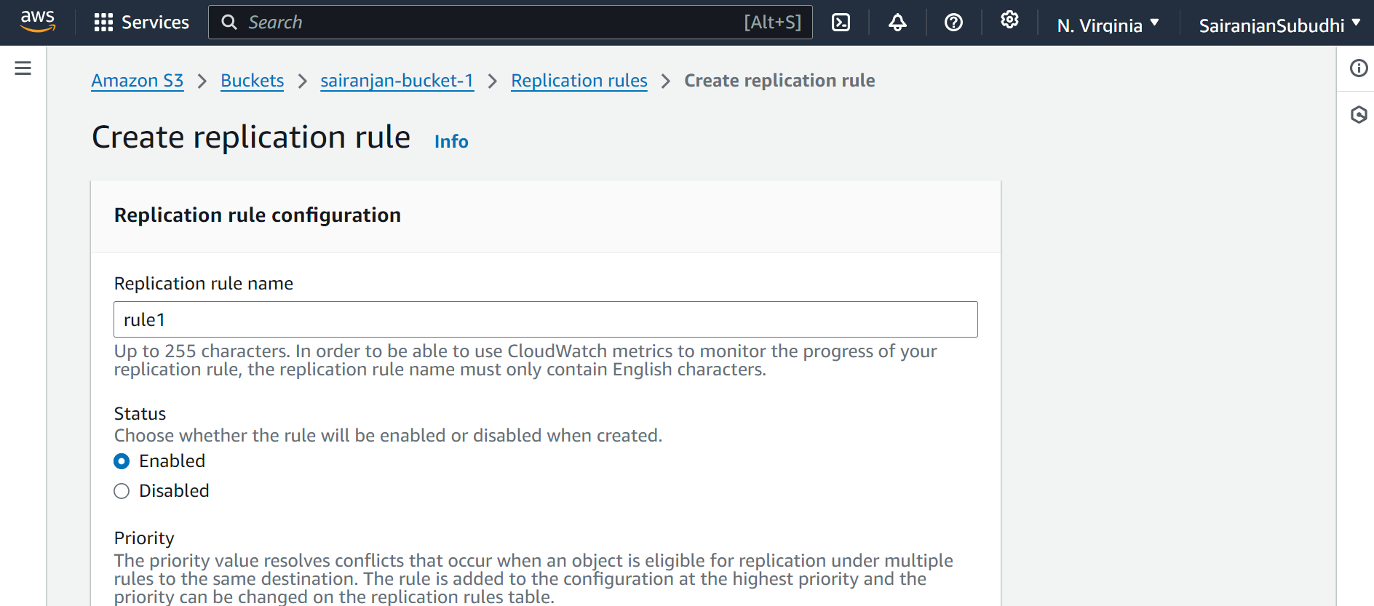

* Choose role scope – ‘*apply to all objects in the bucket.’*

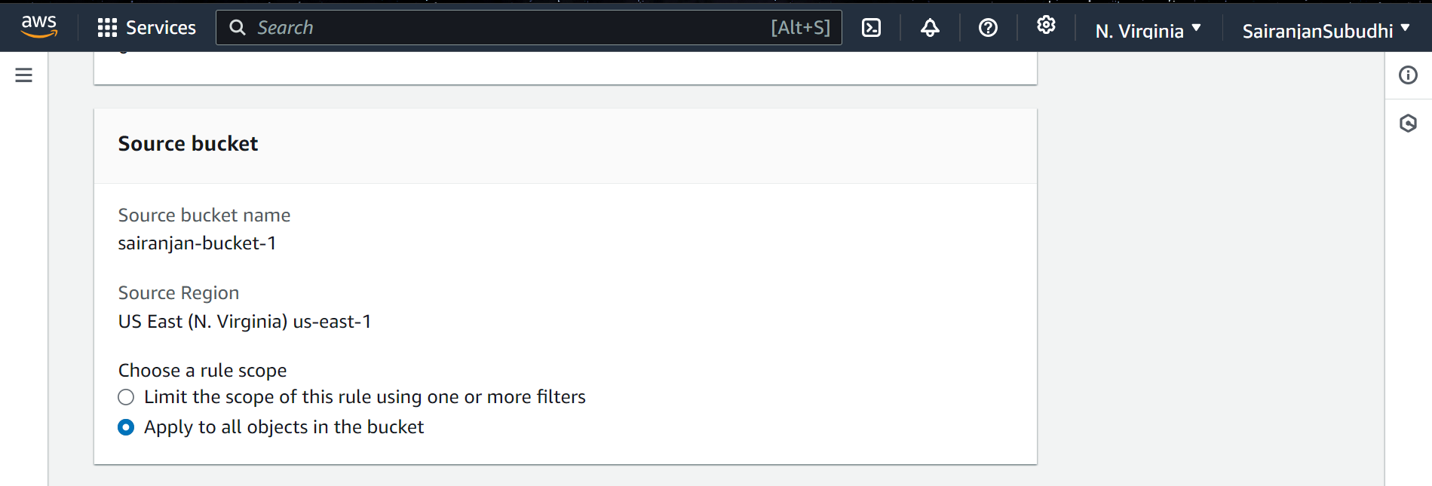

* IAM role – *‘Create new role.’*

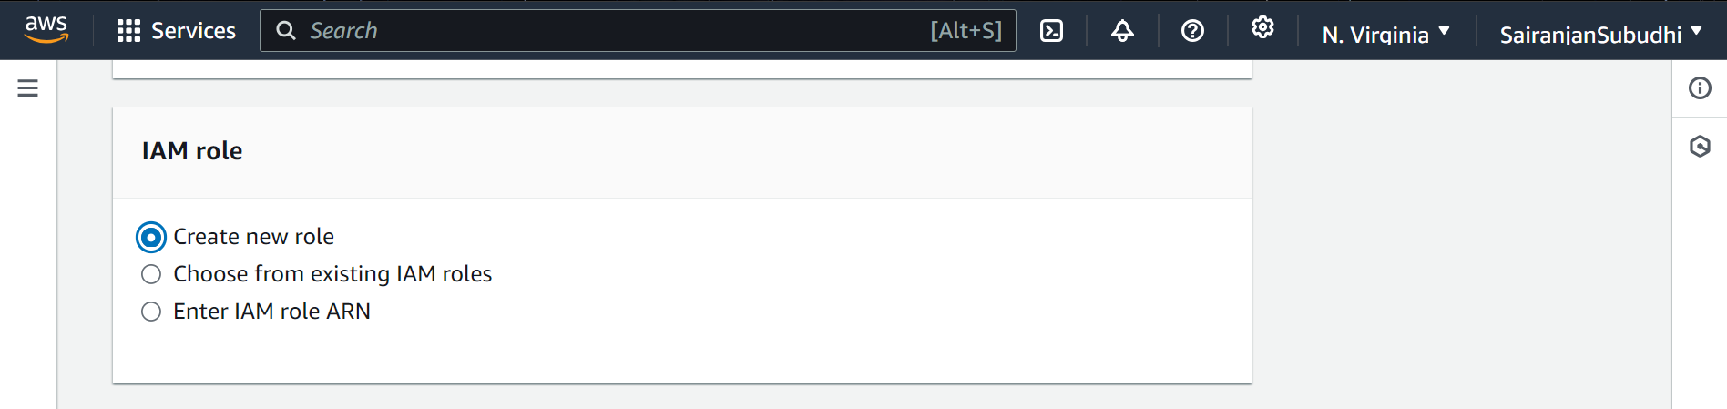

Choose 2nd bucket with Europe region as the destination bucket.

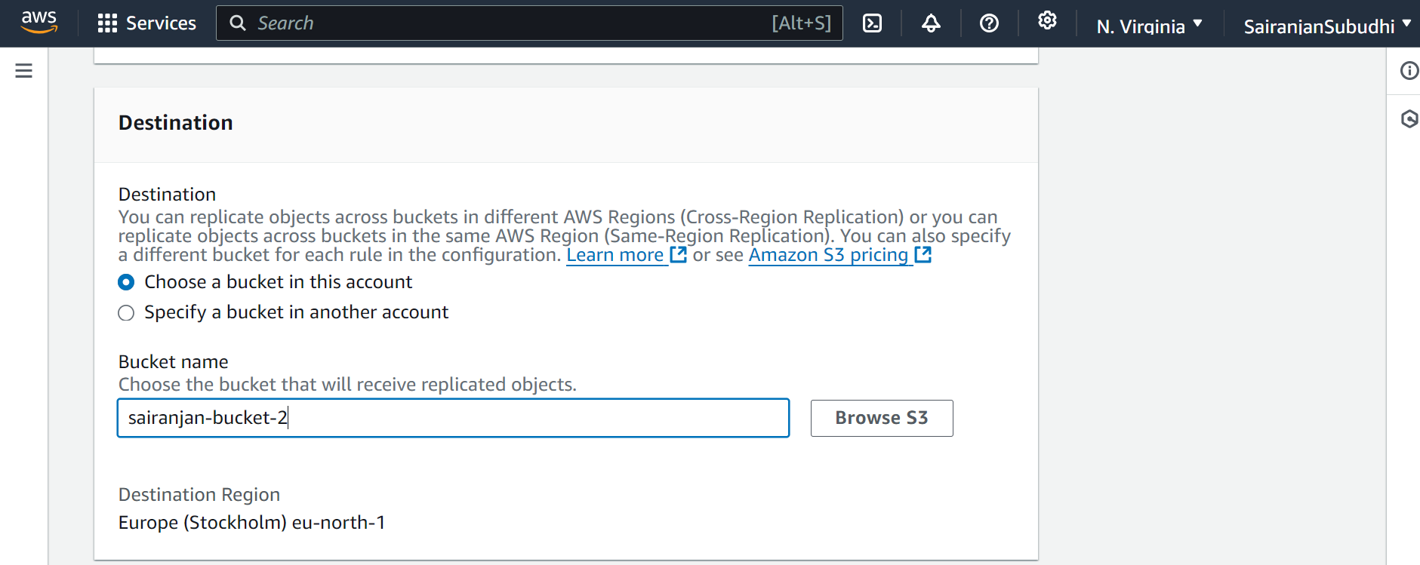

Save the replication rules

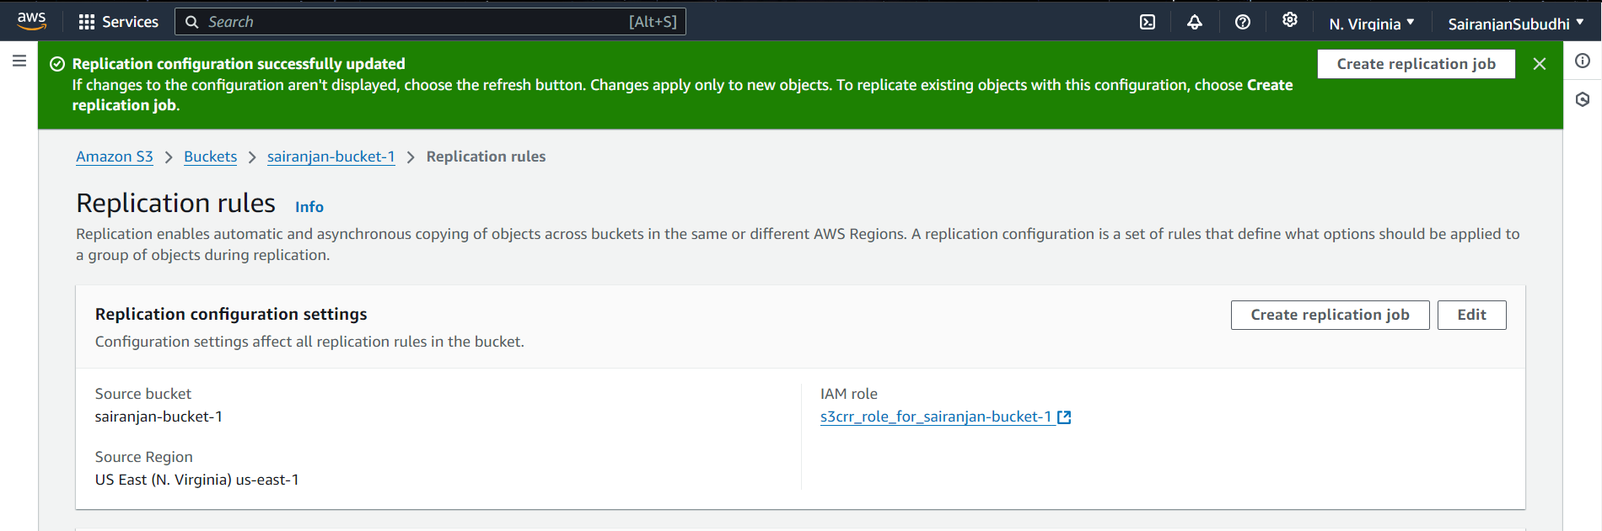

Adding objects to ‘sairanjan-bucket1’. Upload > Add files and upload.

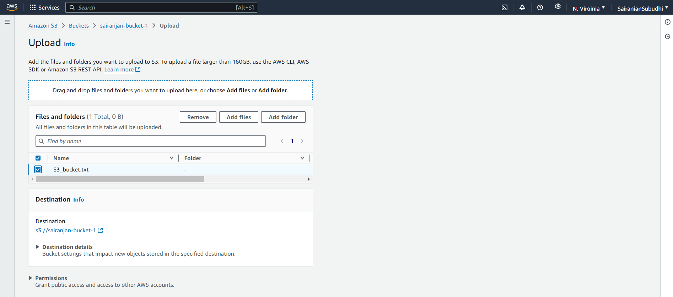

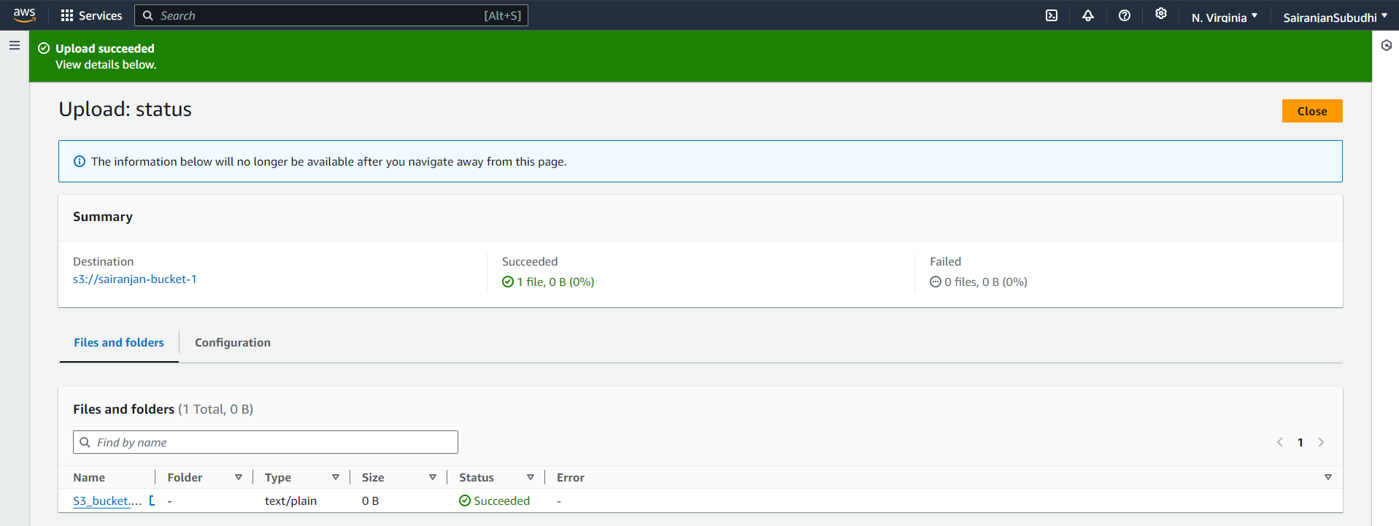

Now in 2nd bucket (destination bucket) in a different region, the file is automatically added due to replication rules.

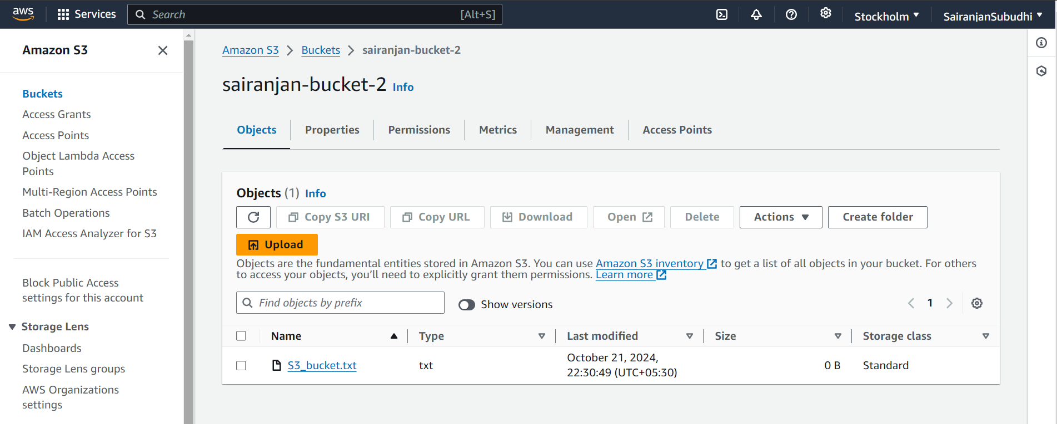

**EXPERIMENT – 3**

**Introduction to Amazon DynamoDB**

Amazon DynamoDB is a fully managed NoSQL database service provided by AWS that offers fast and predictable performance with seamless scalability.

NoSQL database means it doesn't follow the traditional relational database model that uses tables, rows, and SQL for querying. Instead, DynamoDB is schema-less, meaning that different items in the same table can have different attributes, and there is no need to define the structure of data beforehand. This provides flexibility in storing and querying unstructured data as it supports key-value and document data models.

**Task 1 - Create Table**

Search ‘DynamoDB’ and then create table

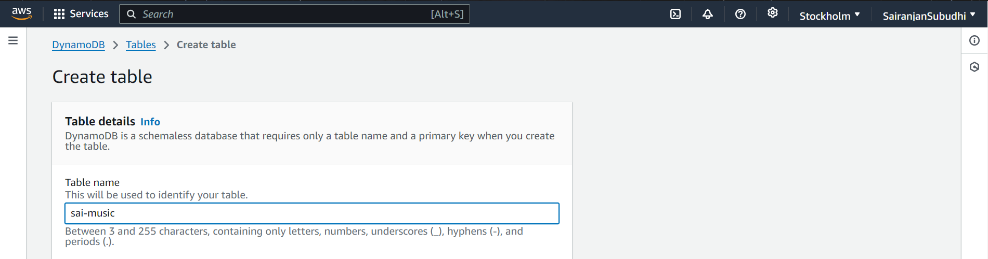

**Partition key and sort key**

The partition key is a single attribute that uniquely identifies an item within a DynamoDB table. It is also known as the hash key or primary key because DynamoDB uses this key to determine the partition (physical storage location) where the data is stored.

The sort key, also known as the range key, is used to sort and organize items within the same partition. Items with the same partition key value are stored together, and the sort key allows them to be uniquely identified within that partition.

A composite primary key consists of two attributes: the partition key and the sort key. This combination uniquely identifies each item within a DynamoDB table. The partition key still determines the partition, but the sort key provides an additional level of granularity.

Specify ‘Artist’ as partition key and ‘Song’ as sort key and click ‘create table’ by keeping rest settings as default.

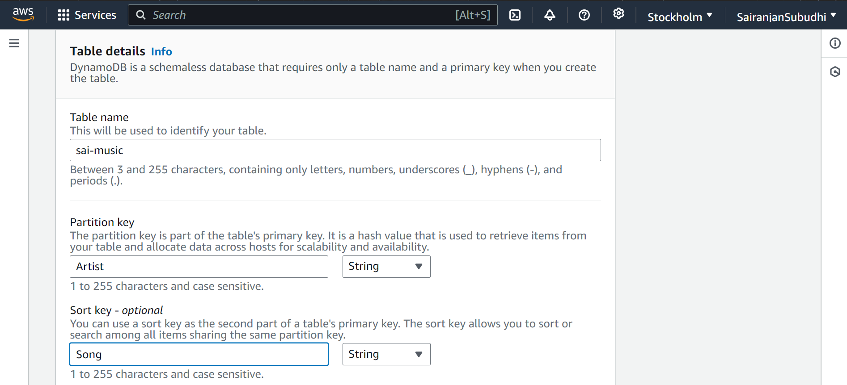

Table *‘sai-music’* created successfully.

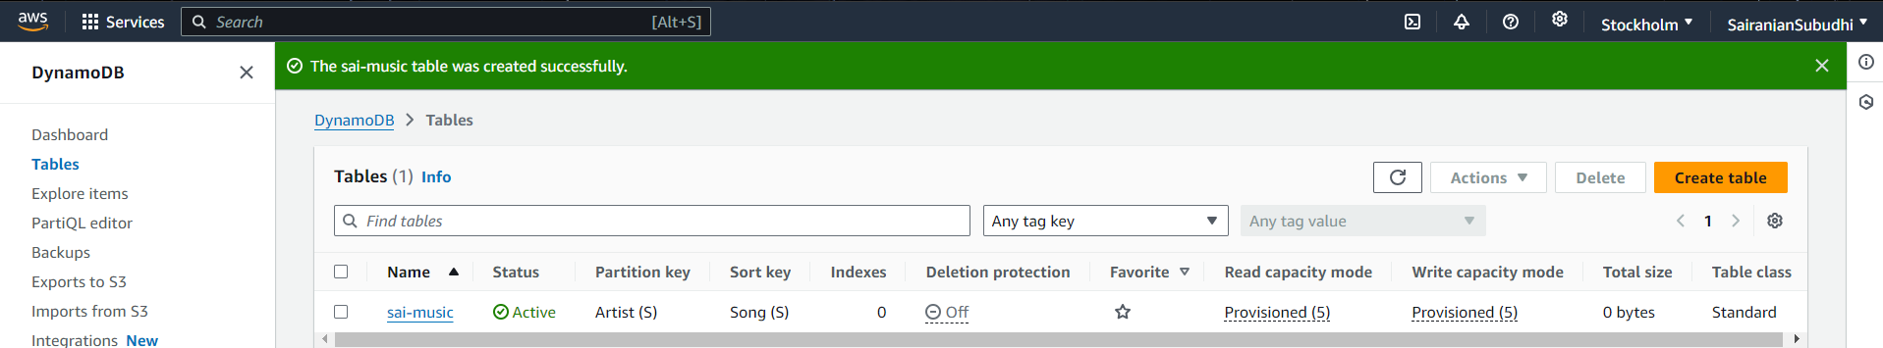

**Task 2 - Entering data in table**

Each table contains multiple items. An item is a group of attributes that is uniquely identifiable among all of the other items. Items in DynamoDB are similar in many ways to rows in other database systems. In DynamoDB, there is no limit to the number of items we can store in a table.

Each item is composed of one or more attributes. An attribute is a fundamental data element, something that does not need to be broken down any further. Attributes in DynamoDB are similar columns in other database systems, but each item (row) can have different attributes (columns).

Now click on the table and navigate to ‘actions’ and select ‘create item’

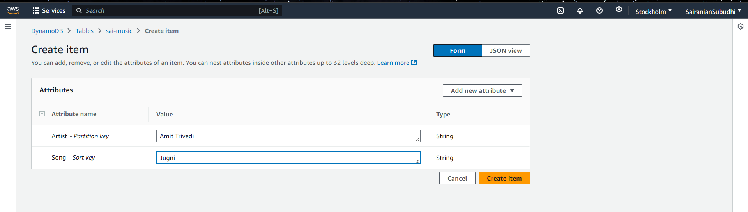

Now create additional attributes by clicking on ‘add new attribute’ button and select ‘string’ from the dropdown.

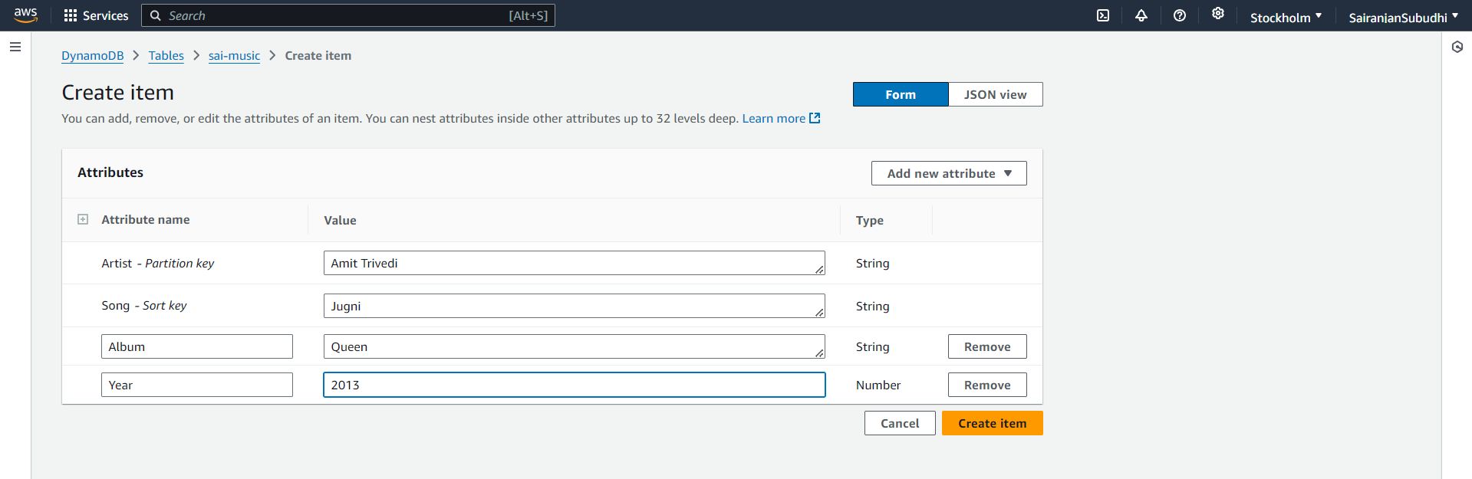

Similarly create two more items.

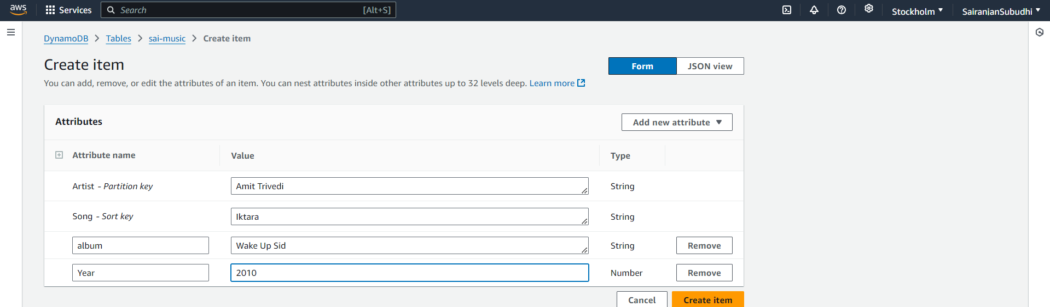

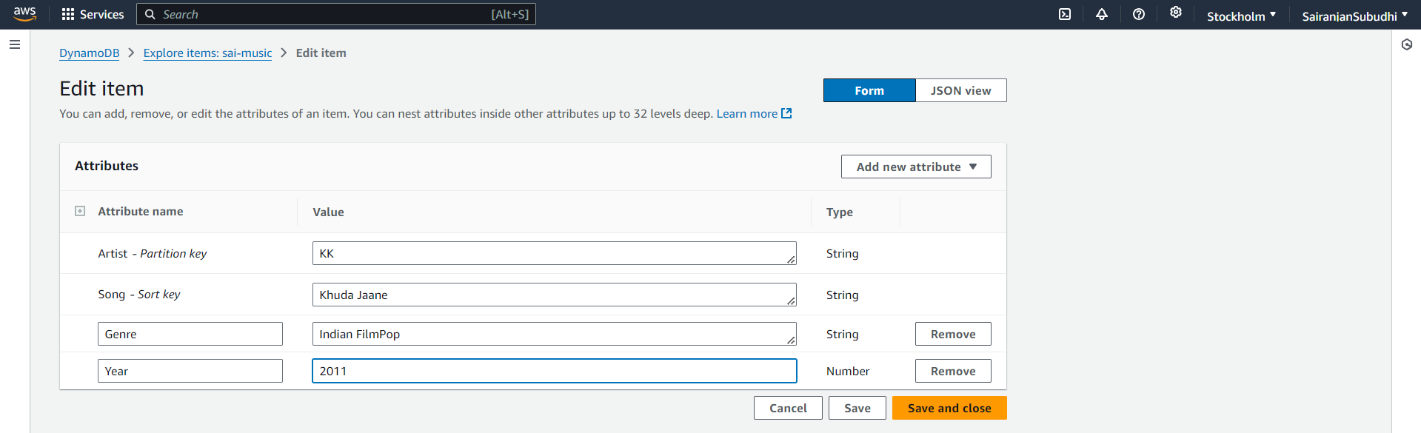  
  
Total items –

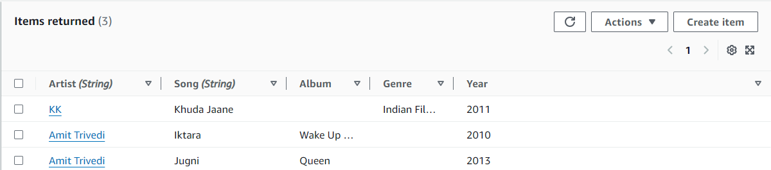

**Task 3 - Modifying Table**

In case there is some error in the data entered, table needs to be modified.

Changing Year from 2011 to 2012 for KK.

Click Psy and change the data.

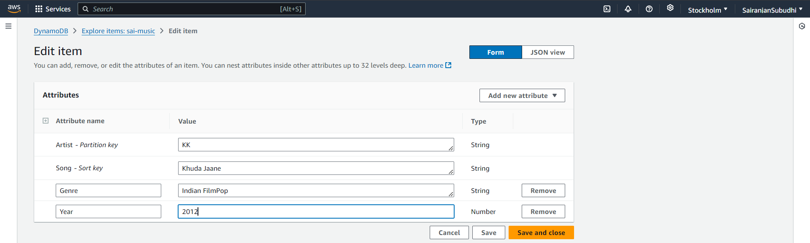

Now click ‘Save and close’ to update the item.

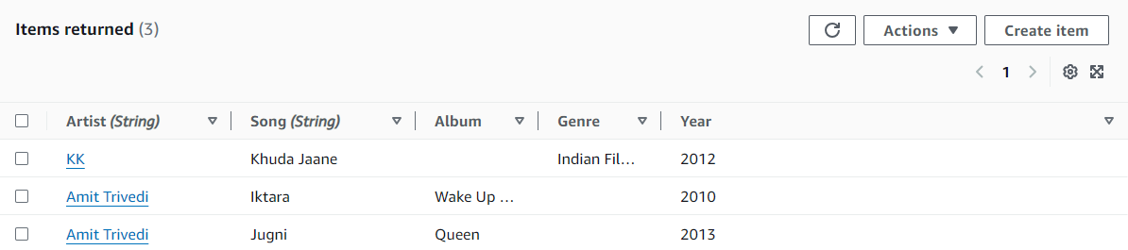

**Task 4 - Querying Table**

There are two ways to query a DynamoDB table: Query and Scan.

A query operation finds items based on partition key and optionally sort key. It is fully indexed, so it runs very fast. Scan involves looking through every item in a table, so it is less efficient and can take significant time for larger tables.

1. **Using query**

Go to ‘Query’ tab and enter fields for the partition and sort key

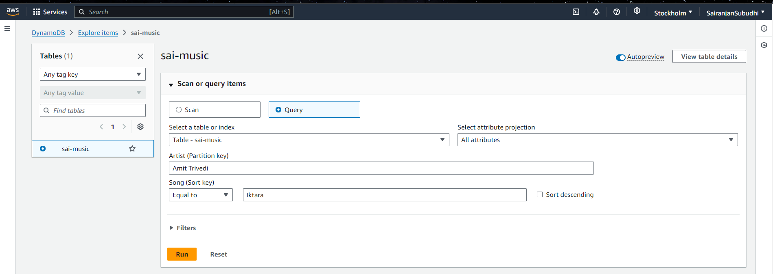

Now click ‘Run’ button to fetch the query results.

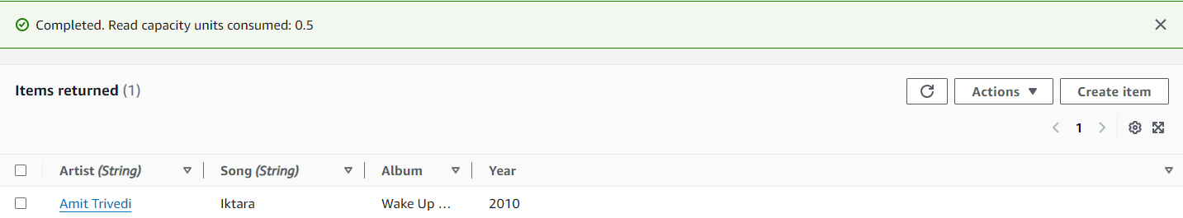

1. **Using Scan**

Go to ‘Scan’ tab and enter attributes and value that needs to be searched.

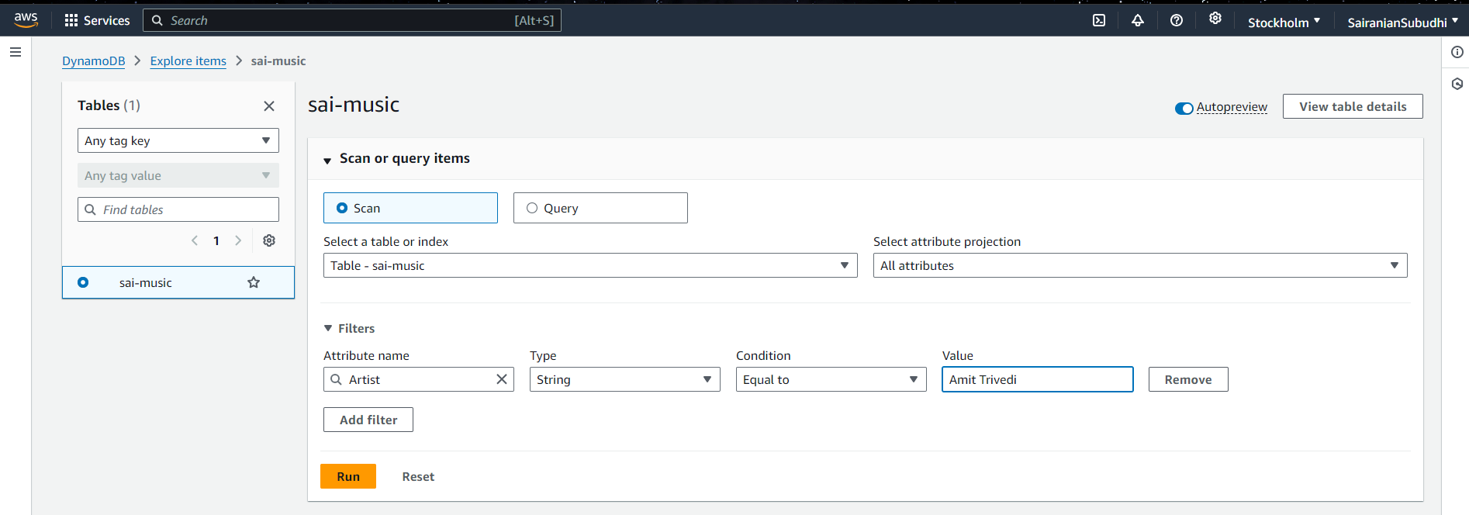

Click ‘Run’ to fetch the results.

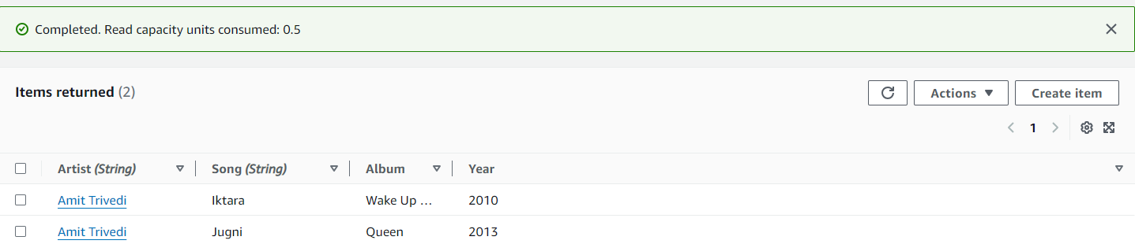

**Task 5 – Delete the table**

To delete the table with all its data, tick the checkbox of desired table and click on ‘delete’ button.

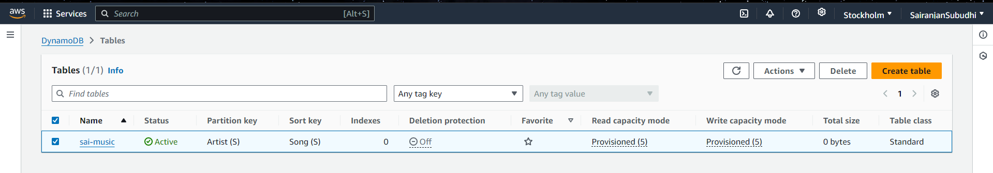

Give confirmation for table deletion and click on ‘delete’ button.

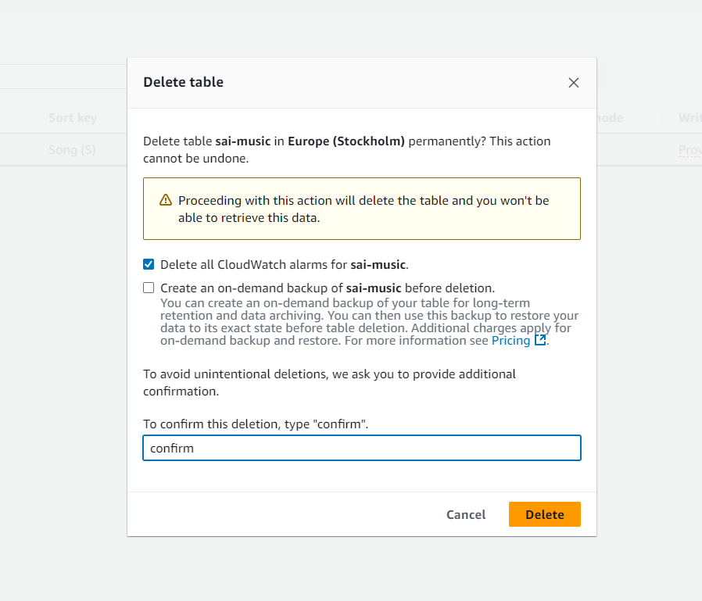

The table will be deleted.

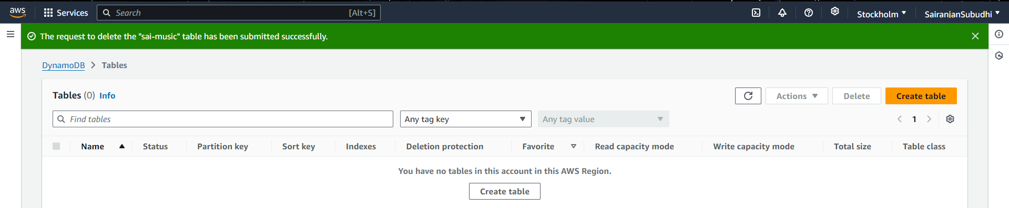

**EXPERIMENT – 4**

**Welcome to EC2 and EBS**

**Elastic Block Storage (EBS)** is a block type durable and persistent storage that can be attached to EC2 instances for additional storage. Unlike EC2 instance storage volumes which are suitable for holding temporary data, EBS volumes are highly suitable for essential and long-term data.

EBS is highly durable, offering automated backups (snapshots) and redundancy within an AWS region. It supports a variety of workloads, including databases, file systems, and applications that require low-latency access to data. EBS volumes can be dynamically resized, and there are different volume types to optimize cost and performance based on specific needs.

**S3 vs EBS**

|  |  |  |
| --- | --- | --- |
| Feature | Amazon EBS (Elastic Block Store) | Amazon S3 (Simple Storage Service) |
| Storage Type | Block storage (like a hard drive) | Object storage (files, media, backups, etc.) |
| Access | Accessible only from attached EC2 instances in the same availability zone | Accessible globally via HTTP/S APIs |
| Use Case | Databases, file systems, applications needing low-latency, frequent access | Storing large unstructured data like backups, media files, logs |
| Data Replication | Replicated within a single Availability Zone | Replicated across multiple Availability Zones (higher durability) |
| Durability | High durability (single Availability Zone) with snapshots stored in S3 | 99.999999999% durability (11 nines) across availability zones |
| Persistence | Persists beyond instance termination if "Delete on Termination" is disabled | Persists until explicitly deleted by the user |
| Pricing Model | Charged based on volume size (per GiB) and IOPS | Charged based on storage, requests (PUT, GET), and data transfer |
| Scalability | Fixed-size volumes, can be resized manually | Highly scalable without predefined limits, pay for what you store |
| Snapshots | Snapshots are stored in S3 for providing backups | No snapshots (data is versioned and can be archived) |

**Each time EC2 instance is created, by default an EBS volume is assigned to it.**

The size of this default EBS volume depends on the Amazon Machine Image (AMI) used to create the instance. For Amazon Linux 2 and Ubuntu AMIs, the default root EBS volume size is typically 8 GiB and for Windows is 30 GiB.

Create a new EC2 instance by the name ‘sai-instance’

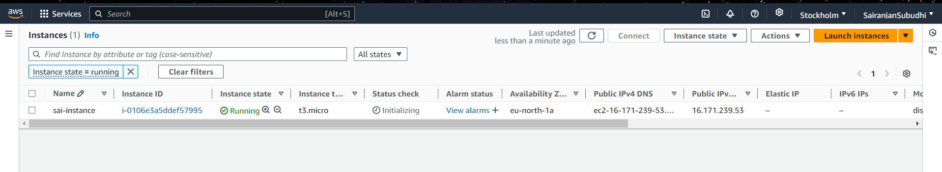

Navigate to ‘Elastic Block Store’ > ‘Volumes’ from the left pane

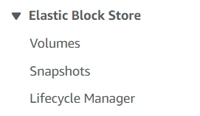

This displays the default volume attached with the EC2 instance

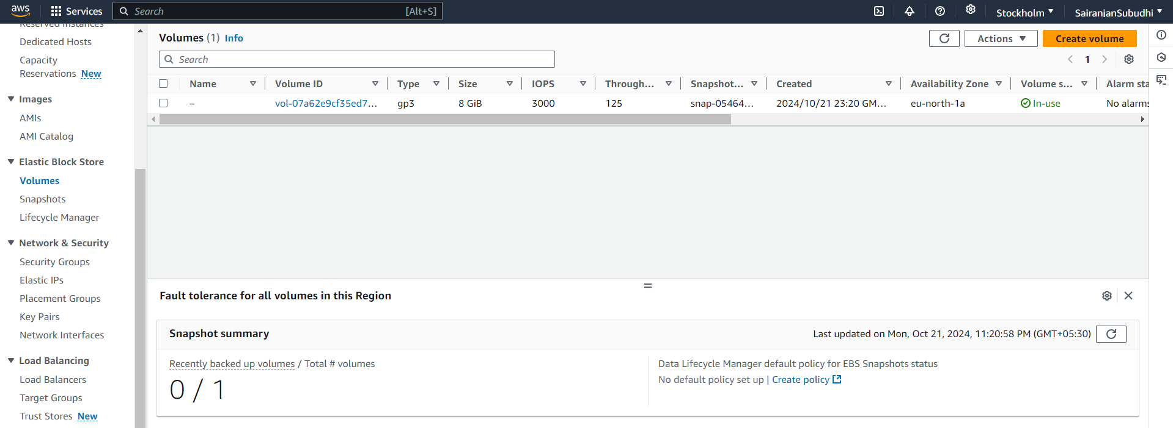

**Usability of this default volume with EC2**

The default EBS volume attached to an EC2 instance serves as the root volume, storing the operating system and essential system files needed for the instance to boot and function. It can store application data, though additional volumes can be attached. Data persists beyond instance stops or reboots, but can be deleted if "Delete on Termination" is enabled.

**Snapshots**

Snapshots are backups of EBS volumes that are stored in Amazon S3. They capture the state of an EBS volume at a specific point in time, creating a backup that can be used to restore the volume later.

Navigate to ‘Snapshots’ in the left pane under ‘Elastic Block Storage’

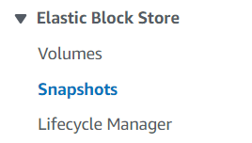

Click on ‘Create snapshot’ to create and capture the desire snapshot

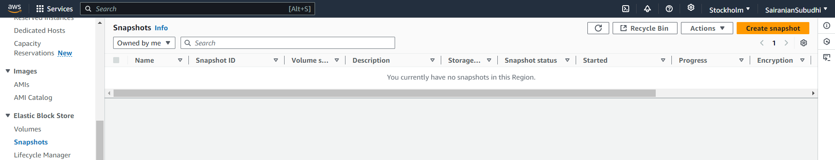

**Deleting the default volume**

By default, the "Delete on Termination" option for an EBS root volume is enabled when an EC2 instance is launched. This means that **when the instance is terminated, the root EBS volume will be automatically deleted**, along with any data stored on it and we cannot delete it explicitly.

Go to ‘volumes’ and select the given default volume. Then click on ‘Actions’ and notice that the ‘Delete volume’ is disabled.

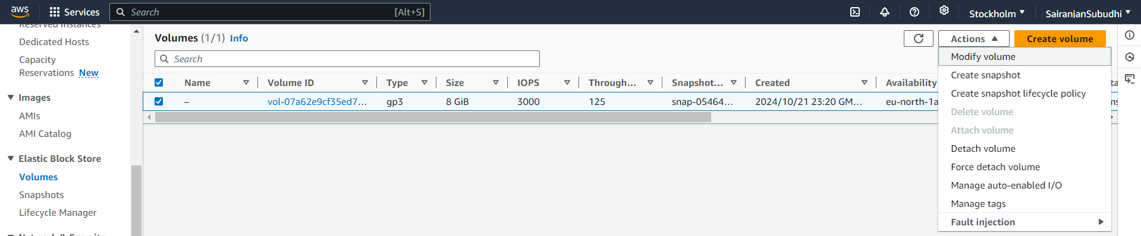

**Detaching the default volume**

Go to ‘volumes’ and select the given default volume. Then click on ‘Actions’ and select ‘Detach volume’.



The root volume (default EBS volume) cannot be detached from a running instance.

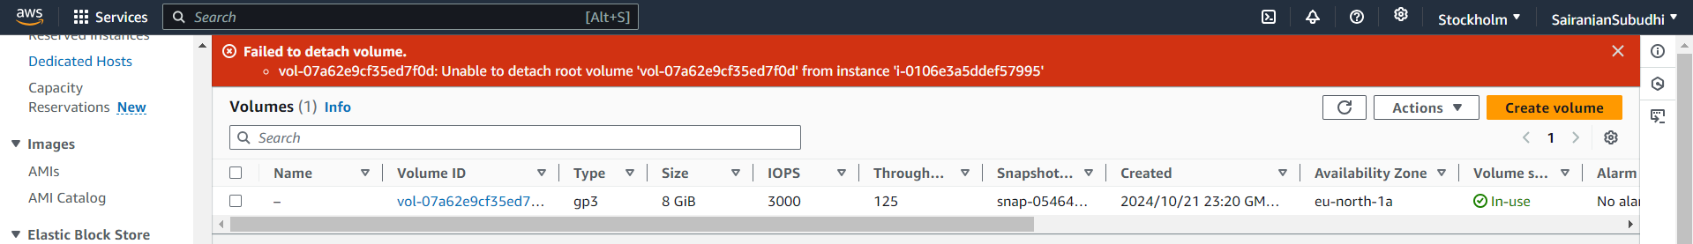

**Additional EBS Volumes**

Other than default volumes, we can create multiple volumes.

Click on ‘Create volume’ button

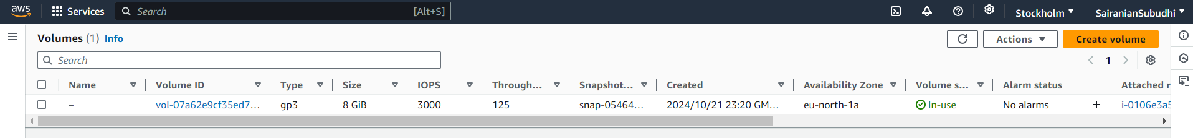

Default size is 100GiB and default availability zone is ‘ap-south-1a’ for custom volume but we can modify it as per our need

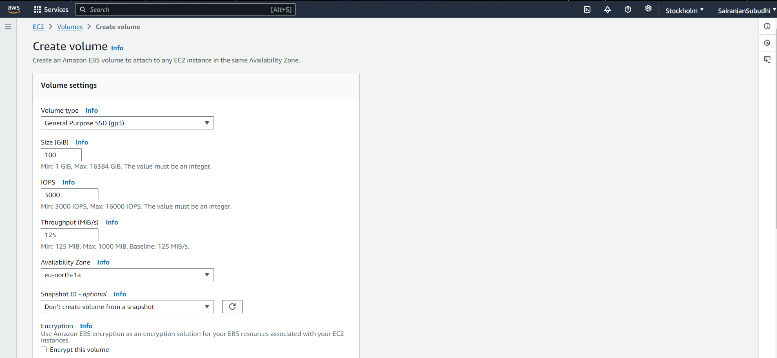

Change the availability zone as per the availability zone of the EC2 instance so that it can be attached later.

Then click ‘create volume’

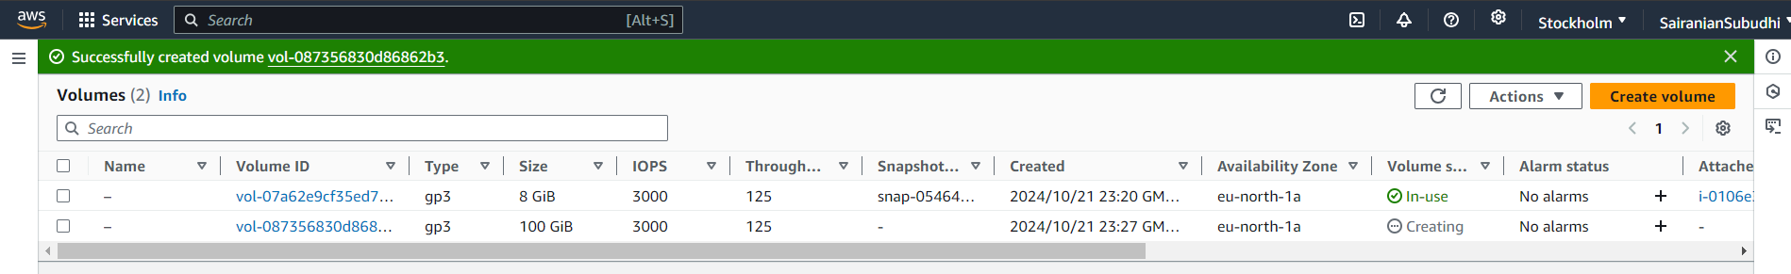

We can use this volume only when it is attached with some EC2 instance. If we won’t attach it shows that volume is ‘available’ but not ‘In-use’ like the root volume.

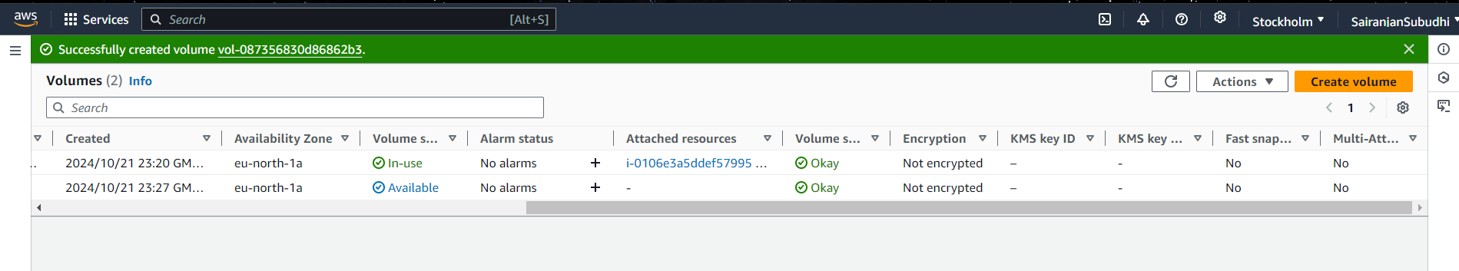

**Attach volume**

EBS volumes are specific to availability zones and can only be attached to instances within the same availability zone.

Select the EC2 instance and then click on Actions and select ‘attach volume’

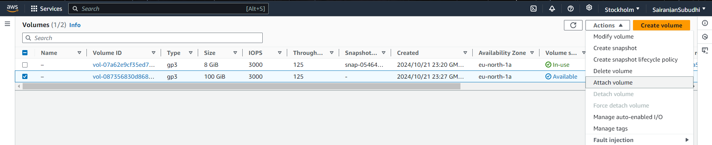

Then select the EC2 instance you wish to attach the volume with

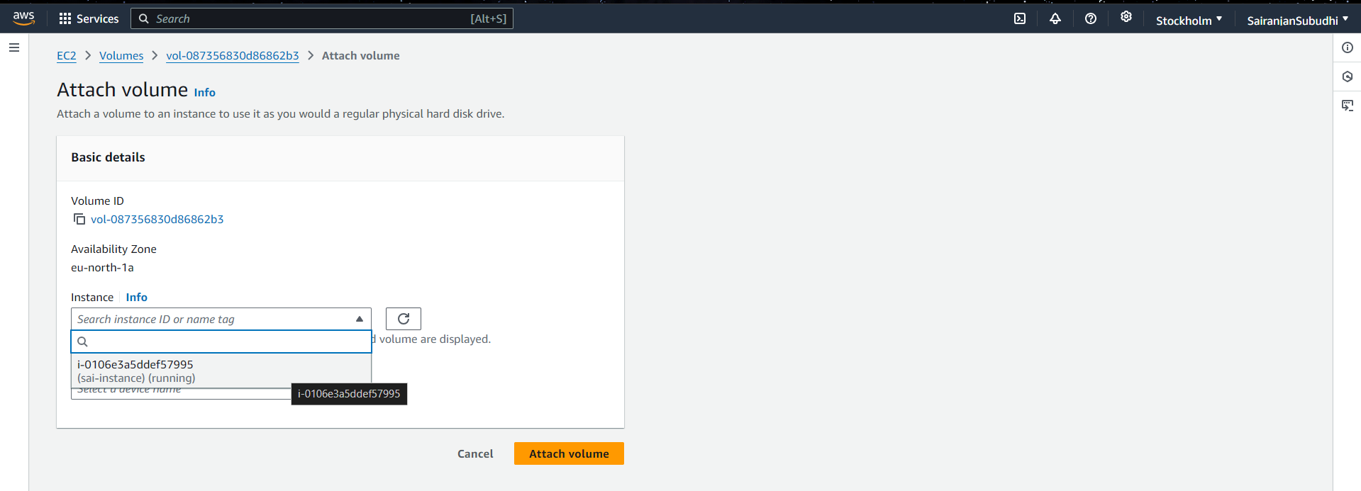

Then click on ‘Attach Volume’. Notice that the ‘volume state’ changes from ‘Available’ to ‘In-use’ once it is attached.

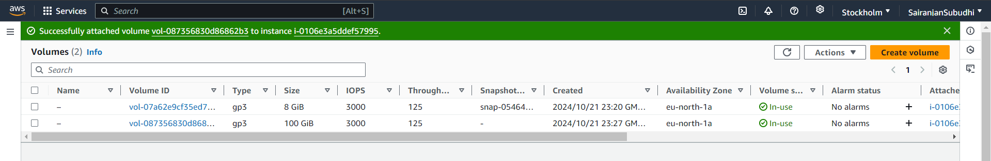

**Detaching the custom created volume**

Select the volume and then click on ‘force detach volume’ under actions.

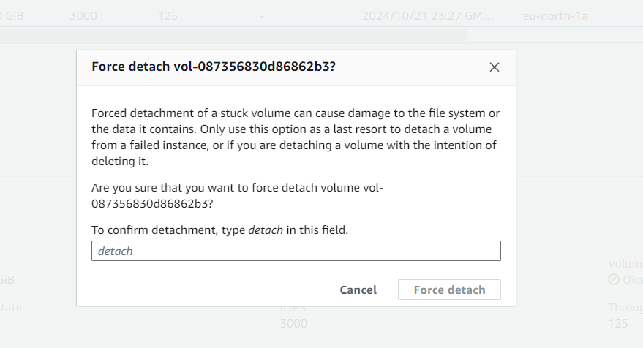

This successfully detaches volume. Notice that the ‘volume-state’ again changes to ‘available’

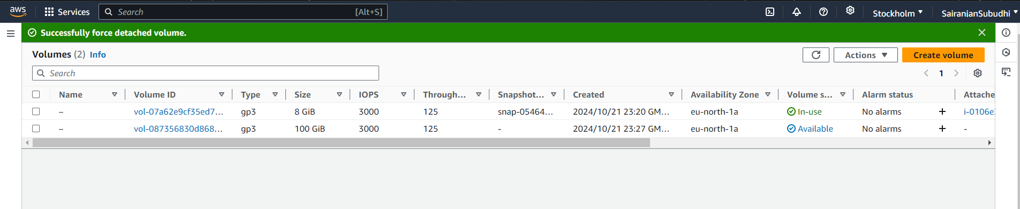

**Deleting the custom volume**

Select the volume to be deleted and then click on Actions > Delete volume

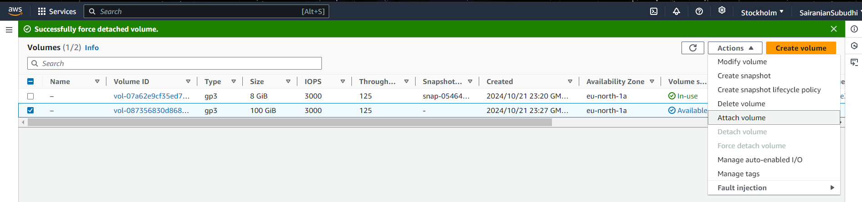

Provide confirmation for deletion

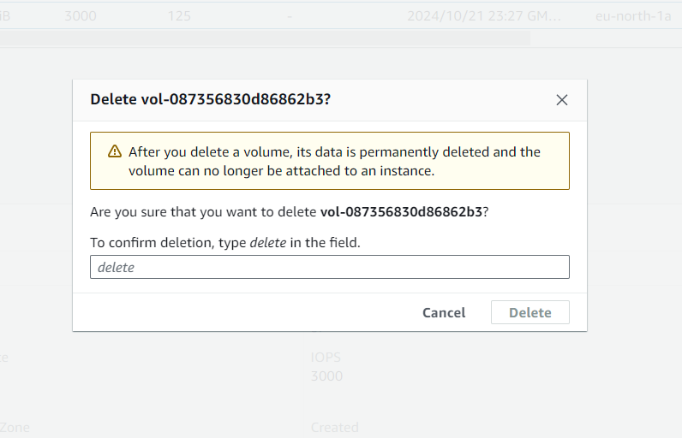

Volume is deleted successfully

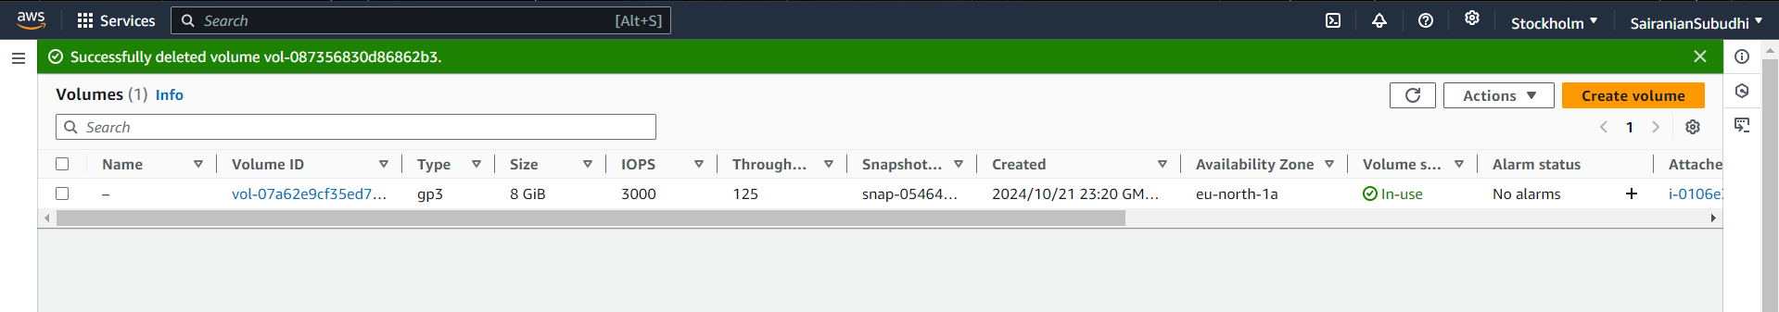

**Deleting the default volume**

To delete default volume – terminate the EC2 instance with which the volume is attached.

Select the instance and click on ‘terminate instance’ under the instance state

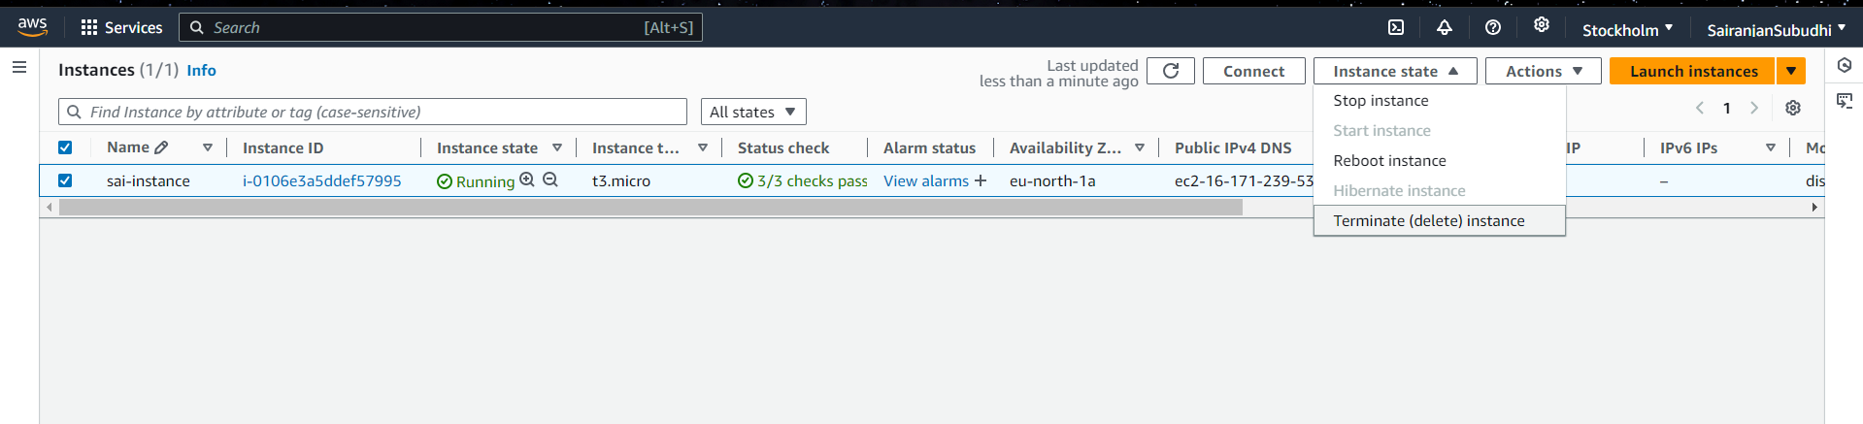

This will terminate the instance

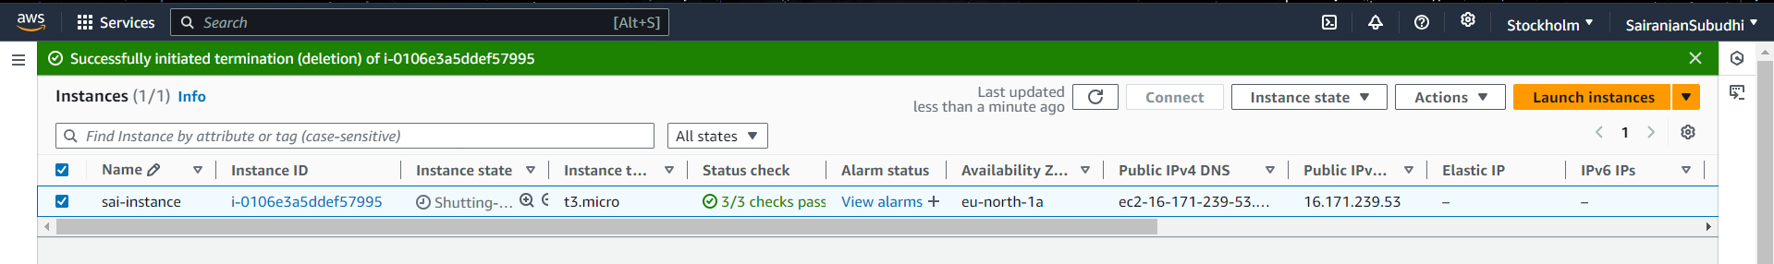

Once the instance is terminated, the volume is automatically deleted.

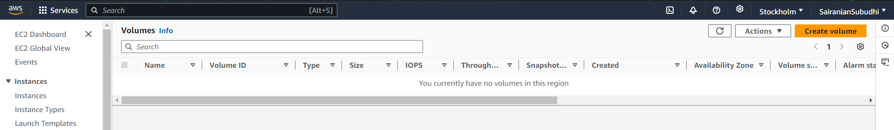

**EXPERIMENT – 5**

**Introduction to Amazon API Gateway**

Amazon API Gateway is a fully managed service provided by AWS that allows developers to create, publish, maintain, monitor, and secure APIs at any scale. It supports building RESTful APIs, WebSocket APIs, and HTTP APIs, enabling communication between frontend applications (like web or mobile apps) and backend services.

**APIs** (Application Programming Interfaces) are needed because they enable different software systems to communicate and share data or functionality.

APIs let developers reuse existing functionality without rebuilding it from scratch, enhance functionality, enable scalability and allow different applications, services, or platforms to interact and exchange information seamlessly.

**REST APIs**

REST APIs (Representational State Transfer APIs) are a type of web service that follow the principles of the REST architectural style. They enable communication between clients (like web or mobile applications) and servers over the internet using standard HTTP methods.

They are a popular choice for web services due to their simplicity, scalability, ease of use and language-agnostic, meaning they can be used with any technology stack.

**WebSocket APIs**

WebSocket APIs enable real-time, two-way communication between a client (like a web browser) and a server over a single, long-lived connection. Unlike REST APIs, which follow a request-response pattern, WebSockets allow data to be sent and received at any time, making them ideal for applications requiring real-time updates.

**HTTP APIs**

HTTP APIs are simpler, lower-latency APIs designed to handle standard HTTP requests, typically for microservices. They are similar to REST APIs but are more optimized for speed and efficiency, especially in serverless or microservices architectures.

**Lambda**

Lambda function refers to an event-driven compute service which allows developers to run code in response to events without provisioning or managing servers. We only need to write our code and define when it should be triggered (e.g., when a file is uploaded, an API request is made, or a database update occurs). This is termed as **serverless computing service**.

Go to AWS Console and search ‘Lambda’

Create a lambda function by the name ‘sai-lambda’

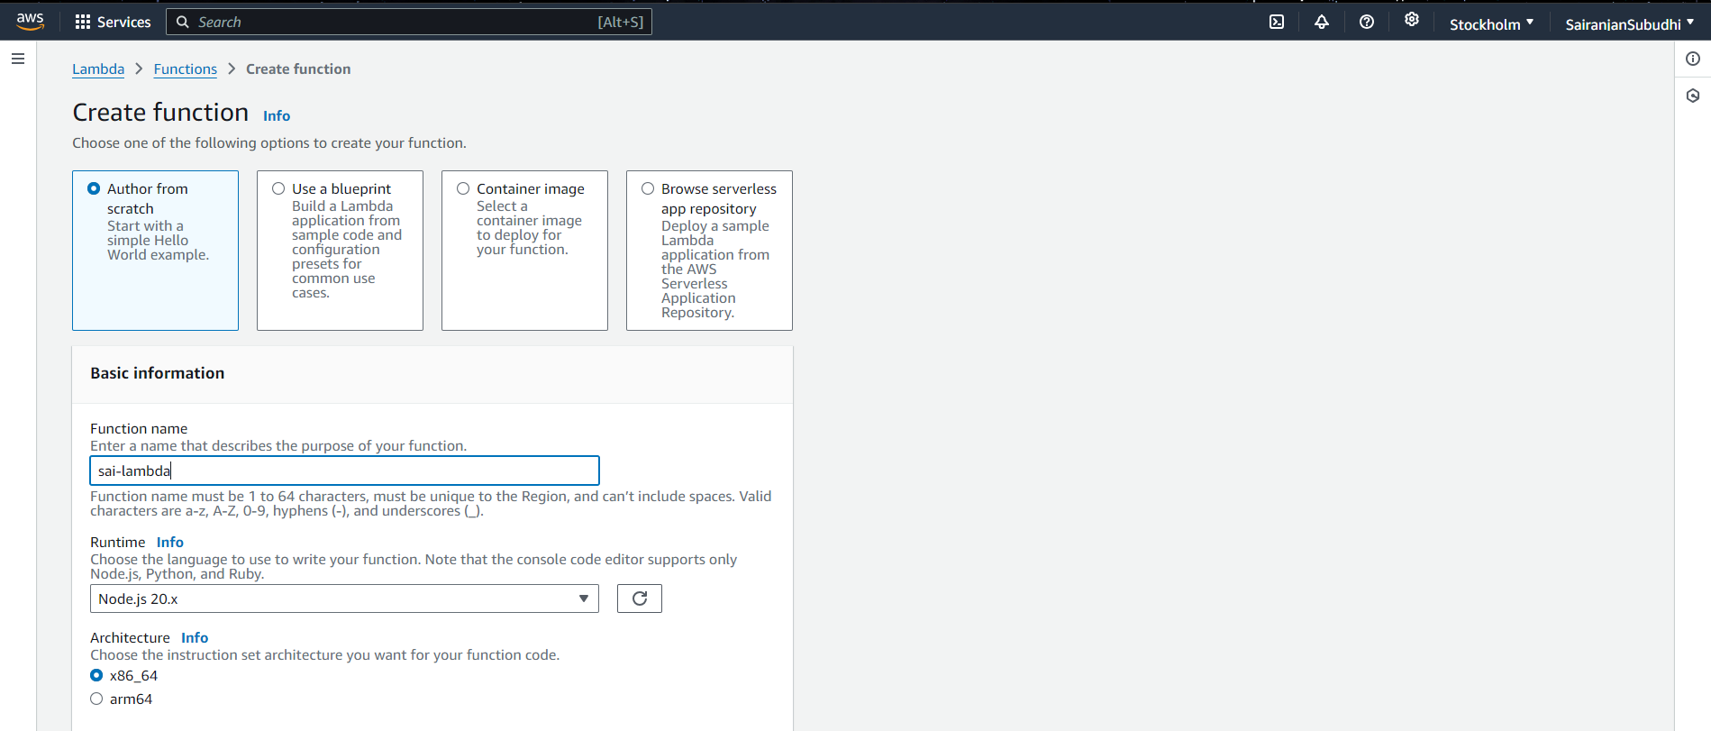

Select any ‘runtime’ as per need. Currently set to ‘Python’

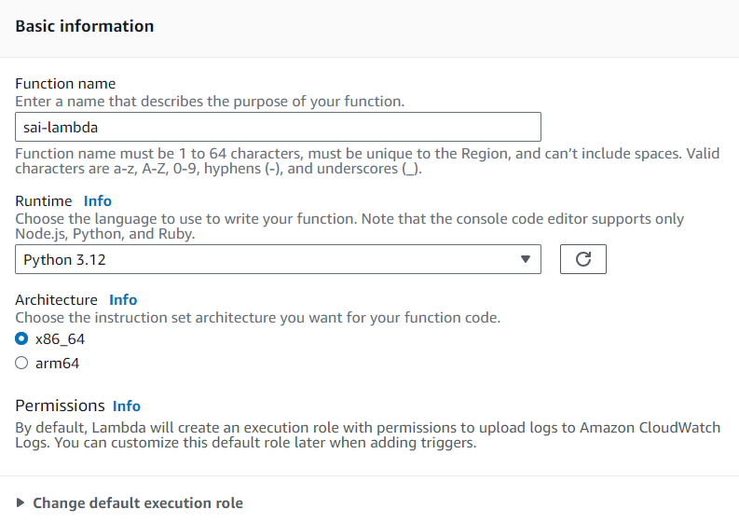

Click ‘Create function’ and lambda function will be created successfully.

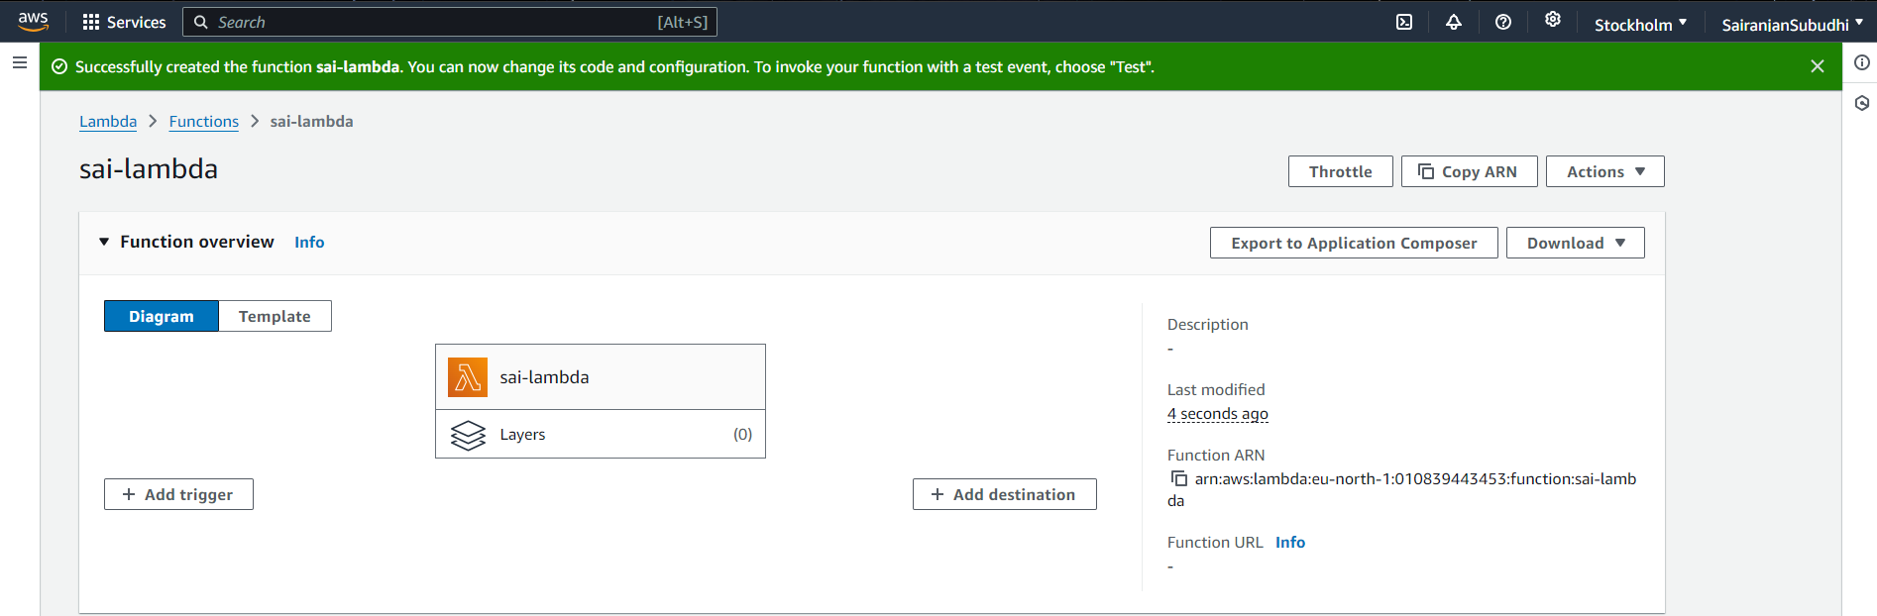

Write code under the ‘Code’ > ‘Code source’ tab

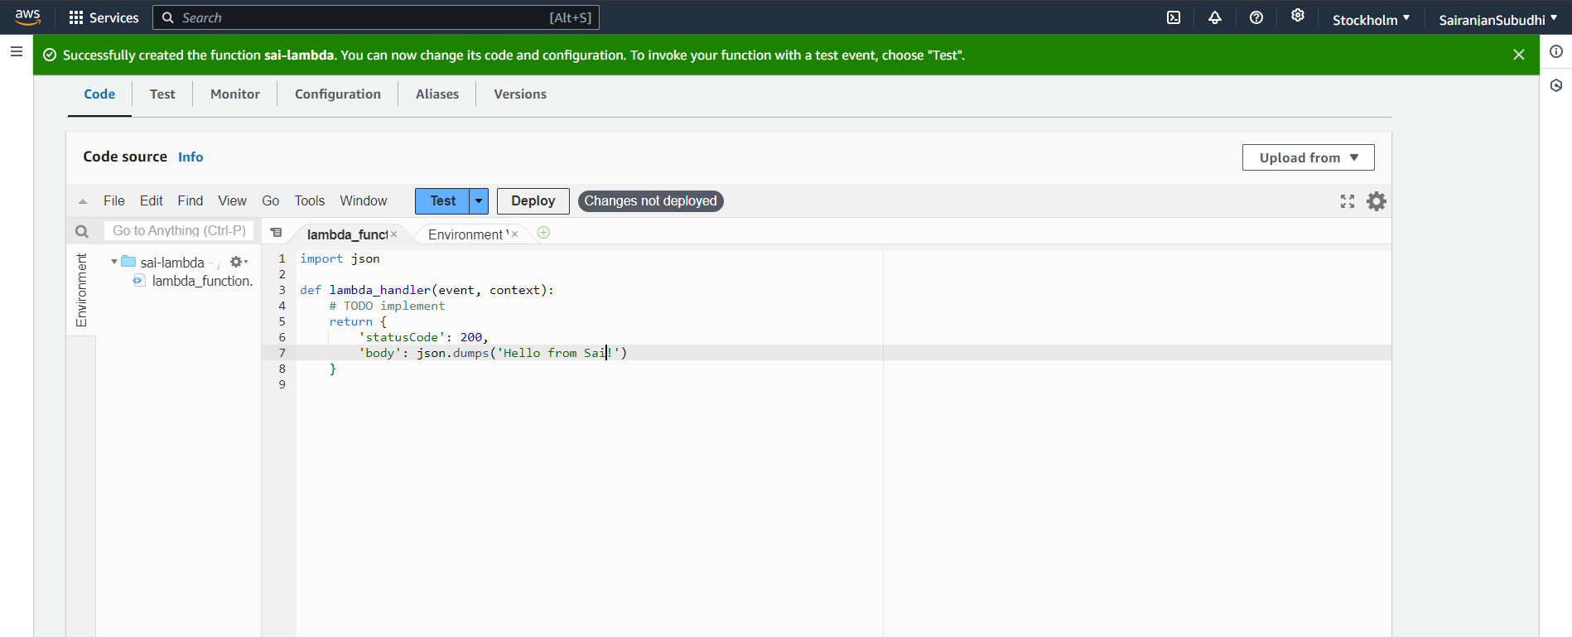

Then click on ‘Deploy’ button to save the changes.

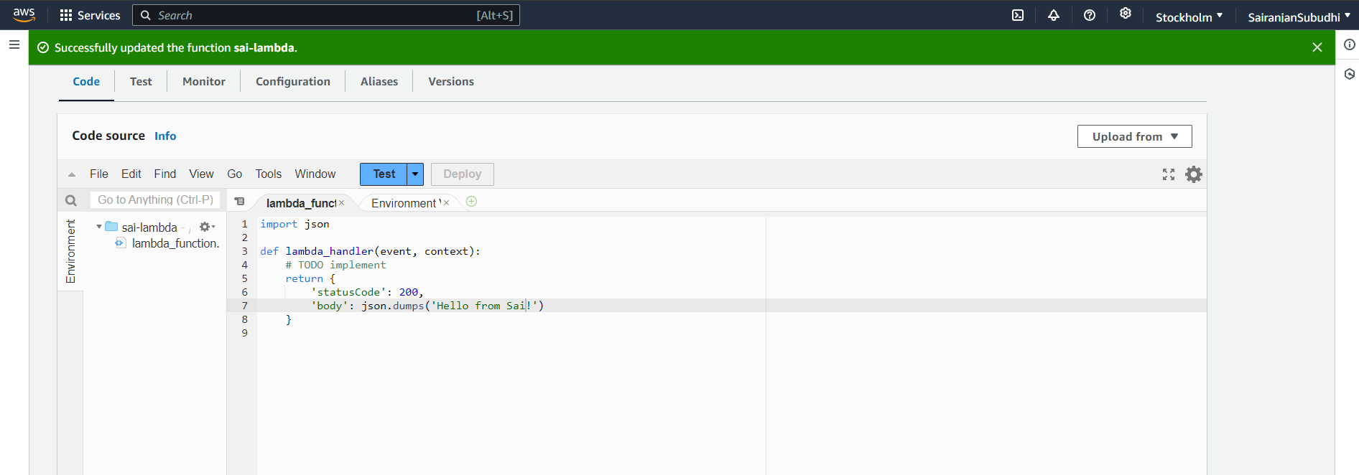

**Access it through API Gateway**

Navigate to API Gateway and explore the various APIs

Choose REST API

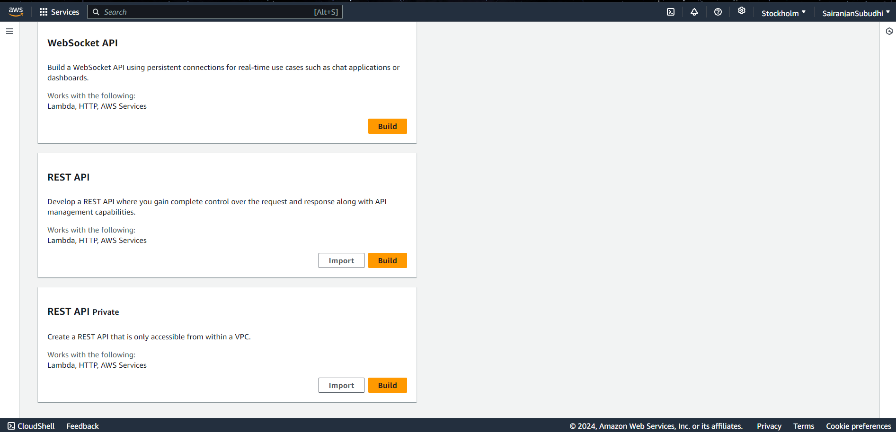

Click on ‘Build’ and then provide the name to the API

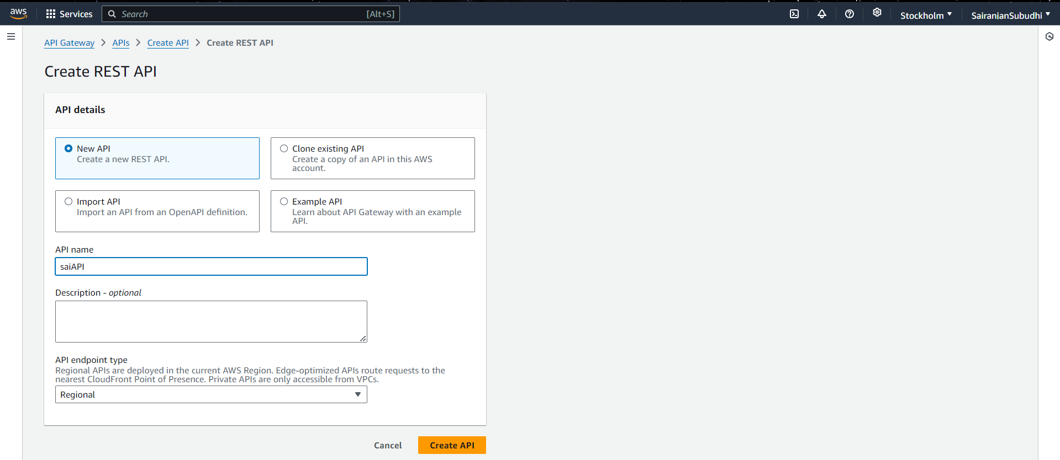

Finally click ‘create the API’ and API will be created successfully.

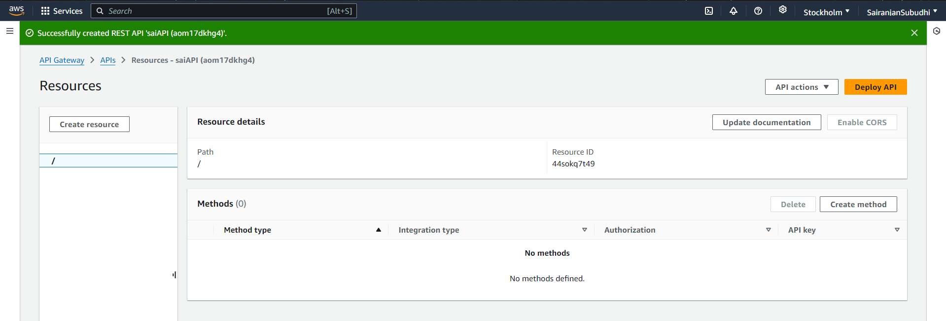

Click on ‘Create method’ before deployment which will be integrated with lambda function.

Set the method type to ‘GET’ which is used to retrieve the data and then deploy and since we have to integrate with our lambda function so integration type will be set to ‘lambda’.

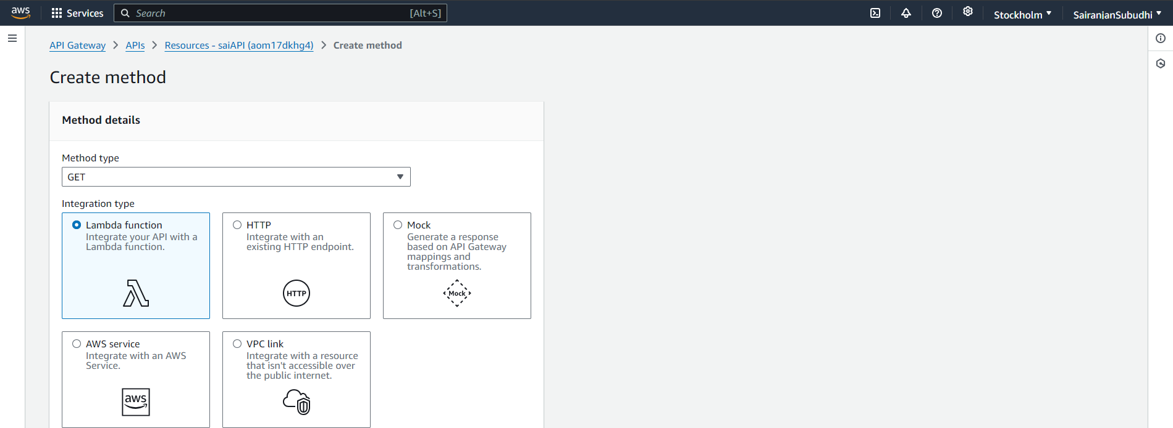

Choose the lambda function created previously.

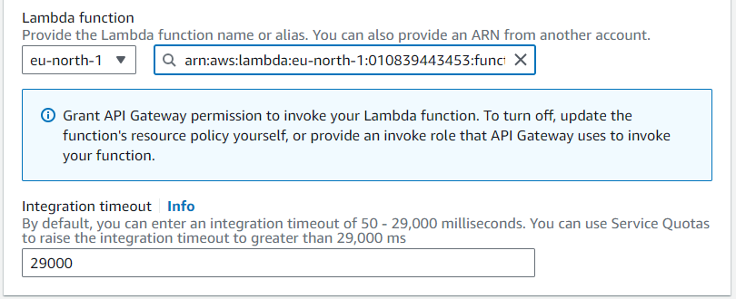

Click ‘Create method’ button

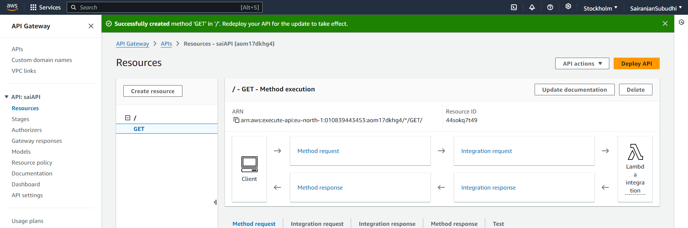

Now we need to click ‘deploy API’ and the set the stage.

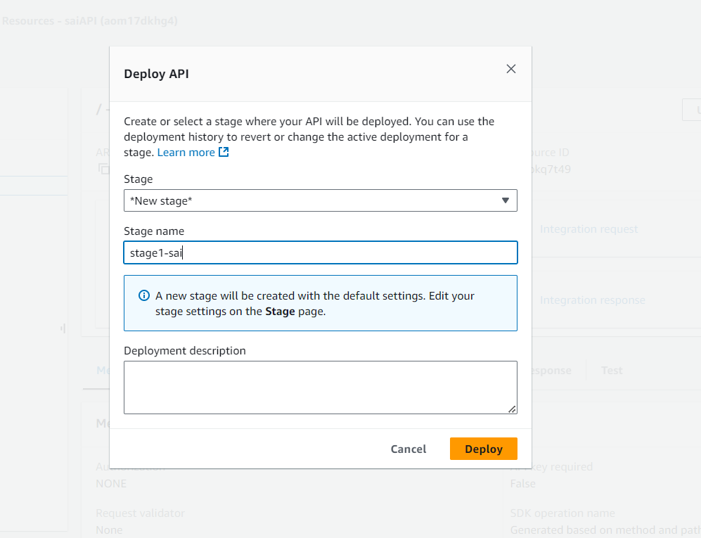

Then click ‘deploy’ which provided an invoke URL.

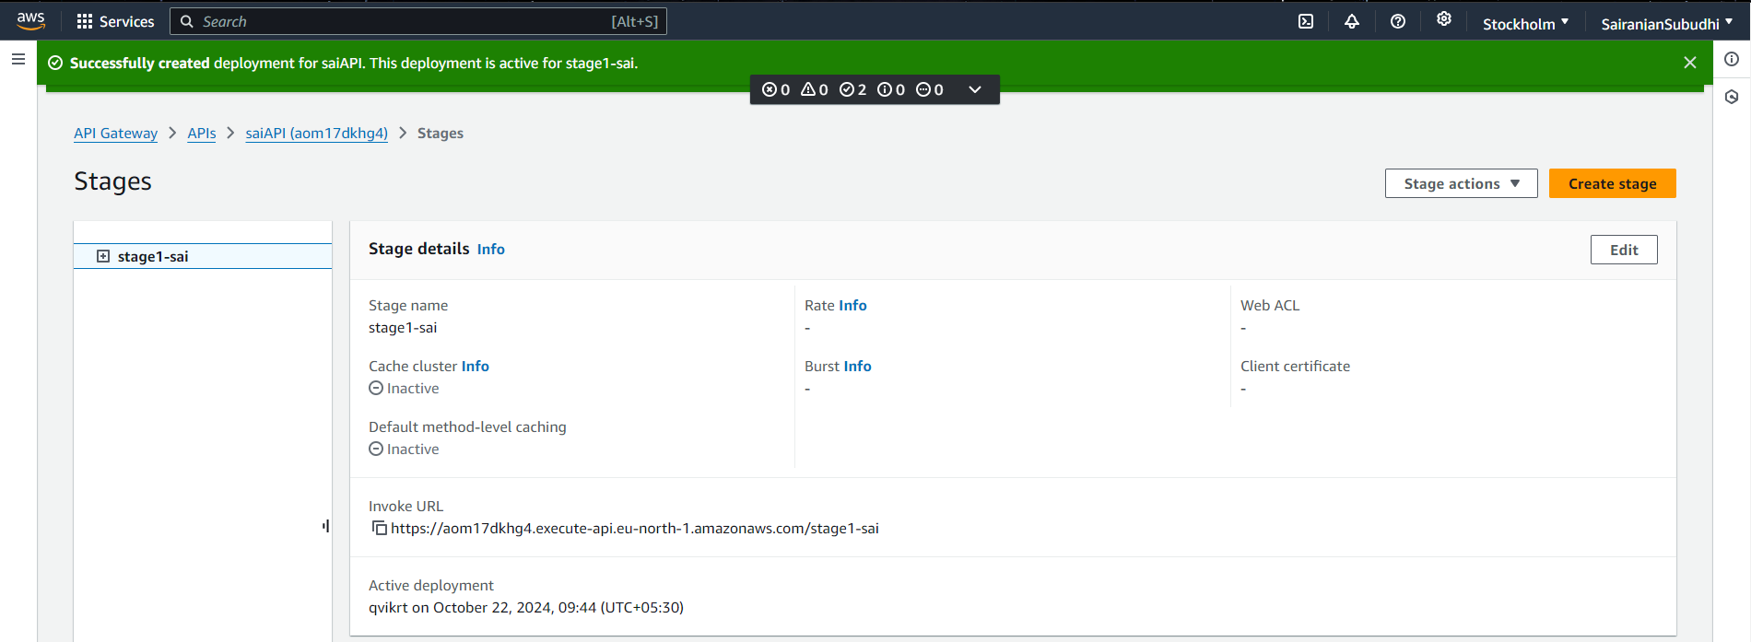

After creating, copy the invoke URL and open it in a new tab.

This URL accesses lambda function under the hood.

It will print the simple code

